2020-2021 Academic Year
2020– 20121

Paideia in Greece

Study Abroad Program

SEE UPDATED WINTER INTERCESSION 2023 INFORMATION ON
PAGES 8-9 !!

Discover the birthplace of

Why Paideia?

Western Civilization

Year Round Programs

We offer semester, winter intersession, spring break, and summer sessions.

Greece is a land of contrasts; picturesque islands, rugged mountains, isolated rural villages and modern cities. Every aspect of this amazing country reveals the diversity, complexity, enthusiasm and
intensity with which life is lived in Greece. With a single glance one
Versatility Over 125 courses to
No matter when you study, expeditions to
choose from

can easily discern aspects of the ancient world, Byzantine culture and contemporary pragmatism. Here you can learn about classical civilization, walk through ancient streets, share the passion of local politics, witness the sites of “Colossus of Rhodes”, other monuments, archeological sites, etc.
PAIDEIA offers the opportunity for students to choose between different programs in Greece.
Excursions

Competitive
Rates

Multiple Locations
archeological sites, museum visits, and activities are included!

From our experience this is the most cost efficient study abroad to Europe.
Greece is your classroom: Choose to study in a city, an island, or a small village.

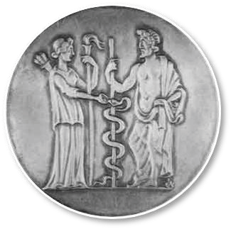

If you do not see a course here, we will do our best to provide it. We want you to meet all your graduation needs.

- All courses are taught in English in small classes exclusive to Paideia students, maintaining personalized interactions.
- Transcripts are issued by Paideia affiliated Greek universities.
- Our courses are accepted by major US universities and taught by professors from:
  - Aristotle University
  - University of Macedonia
  - University of Aegean
  - Hellenic Center of Marine Research of Greece

- Program fees cover housing, one meal per day (dinner), tuition fees, excursions, transfer of credits, orientations, visa assistance, and various cultural activities.
- Paideia offers a truly cultural immersion program in Greece.
- A number of excursions to discover the natural treasures and rich history of Greece are offered throughout the year and are included in the program fee.
- The course menu is rich in Language, History, Archeology, the Arts, Poloitical Science, Marine Science, and Culture
- There may be financial aid and study abroad grant opportunities through your university.
- Internship opportunities are also available.

Your comfort and safety is our priority at all times
Despite Greece’s economic hardship these past few years, Greece remains one of the safest countries in the world. All Paideia students receive an individual pre-departure orientation in person or via telephone to answer all questions and provide you all materials needed. Upon arrival a Paideia staff member will meet you and help you get settled. Once at your destination, an on-site orientation is delivered to help you overcome the feeling of being in a foreign country, give you a boost, and familiarize you with your new surroundings.

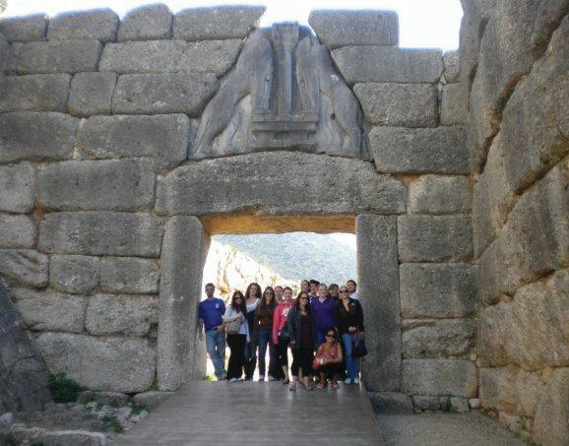
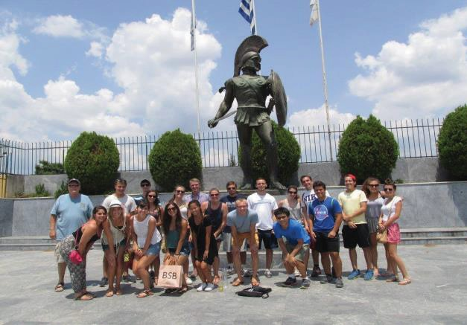

Study tours are included for all students studying with Paideia during the fall or spring semesters, as well as, all winter intersession and spring break students. For those who wish to travel abroad after the academic year concludes, two study tours are offered during the summer break.
Study tours are offered seasonally.
Our study tours are a way to see Greece’s most known sites while learning the history and experiencing the traditions behind them. Here are just some highlights to this fast paced trip around mainland Greece:
- Visit the Acropolis of Athens
- Learn about the oracle, Phidia, in Delphi
- See the “Hot Gates” where Leonidas and his famous 300 took on Xerxes
- Take the athlete’s oath in the ancient stadium of Olympia
- Stand on “Falling Rocks” at Meterora
- Compete in the Appolodurus Race in Aianni
2

The ancient Greek word “Paideia” combines all the ideals of Classical Greece, in unity. It incorporates civilization, culture, discipline, tradition, literature, and education.

Program Management

Costs

The course menu is rich in Language, History, Archeology, Business, the Arts, Culture, Political Science, and Marine
Science.

The academic component of the program is coordinated by the academic director, who is appointed by the collaborating Greek universities. Paideia’s academic directors are highly educated individuals who have served as deans or heads of departments previously.
Every Paideia academic director has pursued higher education in the U. S. and knows the specific needs of the American student. We believe this key component of our program has led to its success.
One to two administrative secretaries are appointed to each academic director by the local universities to facilitate management.
Assistant directors are appointed by Paideia. They serve as vital team members collaborating with university personnel and local authorities on a variety of matters such as housing, meals, transportation, cultural activities, interactions with natives, miscellaneous needs of students, local and national excursions.

Paideia and national universities are responsible for acceptance of students, selection of classes by students, transfer of credit and prior approval.
The total cost of the program for the 2022-2023 academic year is $10,000 per semester, which covers tuition and course fees, room and board, one meal daily (supper) and also lunch with a Paideia scholarship based on merit and need during school days and various student activities.

It does not include personal expenses and transportation to and from Athens, Thessaloniki, or Rhodes. Also, application and registration fees to PAIDEIA affiliated US Universities are not covered.

Please note that fees are subject to change. Any considerable decrease in the value of the dollar will affect the total cost of the program.

Eligibility
A 2.5 GPA or higher is needed for successful enrollment into the Paideia program.
Although prior knowledge of the Greek language is not a requirement, students not familiar with the language must complete an Elementary Modern Greek course.

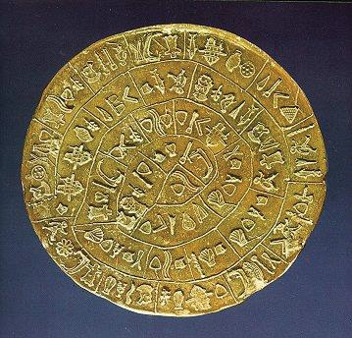
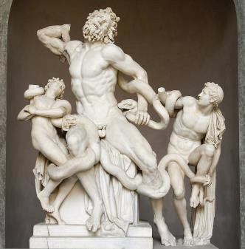

3

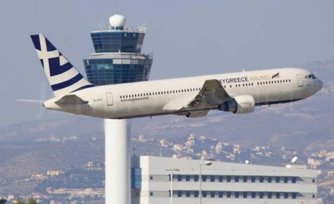

Paideia Scholarship Opportunities

Things to Consider
- Student visas are not required for US citizens staying in Greece up to three months
- While in Greece, remember you are an adult and are fully responsible for your behavior. You must obey all local laws and you are responsible for your academic achievement. Neither your university or Paideia are have liability for any activities you engage in independently of the program
- Paideia reserves the right to dismiss students from the program who break Greek law and university rules
- Class attendance is required for full credit. Students with unexcused absences will receive an incomplete
- Avoid lines at the computer lab or study room and bring your own lap top
- Whether staying at a hotel or a private apartment, all rooms should be left in the original condition. –Trash must be properly disposed and keys left as instructed.
- Students must pay in full for any damages caused to housing properties
Paideia allocates scholarship grants in the range of $100-$1,000 to encourage and help students with studies in Greece.

In addition, a small number of students who otherwise could not afford to study in Greece receive grants over $1,000.

Semester students with a GPA of 3.7 or higher at the time of application automatically receive a $500 US reduction against their tuition fees. Winter intersession and summer students receive $150 US reduction.

This financial assistance is made possible through the Paideia Alumni Fund and the generosity of previous Paideia students.
Students granted a Paideia Scholarship against their tuition must submit a video or written presentation on their experiences abroad prior to departure from Greece.

Trans-Atlantic Flights
You are welcomed to secure your own flight abroad. Alternatively, you can elect for Paideia to organize your travel arrangements.

Travel Insurance
It is a mandatory requirement every students to have study abroad supplemental health coverage for the period of stay in Greece. You can have this coverage through your home university. If not, Paideia suggest HTH worldwide at: www.hthworldwide.com

Proof of purchase must be submitted to program coordinator prior to course registration.

Transfer of Credits
PAIDEIA study abroad programs in Greece are affiliated with various US colleges and universities throughout the country. All credits earned overseas are recorded as direct UConn, URI, HSU, BSU and other affiliated university credits.

All programs are full time (minimum of 12 credits) and courses must be approved prior to departure. Students should also check with their advisors to find out how the credits earned overseas can be applied to the degree program.

4

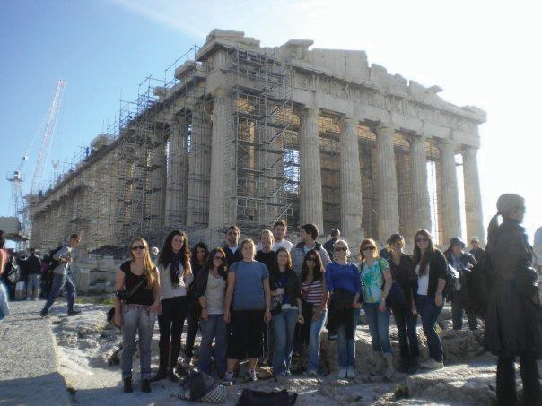
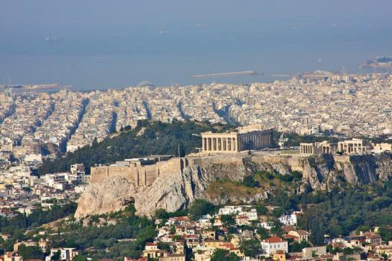
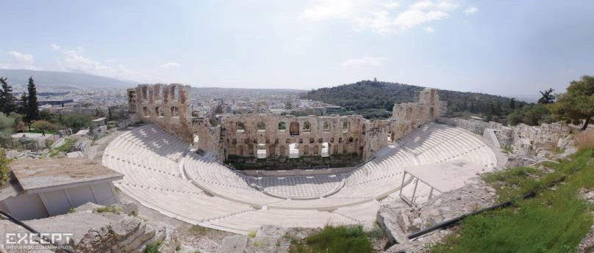

Athens
Study Destinations: Athens
Athens is the largest city in Greece; a classical city full of Classical, Hellenistic, Byzantine, and Modern monuments. Athens is the Center of all the Centers in the world. Athens is the city of the Olympic Idea, the birthplace of Democracy, the city of artists with the Parthenon in the Acropolis of all and for all.
Athens is beautiful and always smiling. You can find the Athenian smile everywhere: in an ancient theater, in a modern exhibition hall, at a sports even, down by the sea, at concert, around the table in a small taverna, in a little alleyway, behind the mast of a sailboat or next to the column of an old temple.
THE NATIONAL AND KAPODISTRIAN UNIVERSITY OF ATHENS
The National and Capodistrian University of Athens (www.uoa.gr) was founded on May 3rd, 1837 and was housed originally on the north east side of Acropolis. It was the first university not only in the newly established Greek state but also in the Balkans and the Eastern Mediterranean in general.
HOUSING
Students in Athens will be housed at rental apartments. Arrangements have been made for one meal daily (supper) and also lunch with a Paideia scholarship based on merit and need, during the school days for the entire semester.
COURSE OFFERINGS
For course offerings please see the course
registration form. The courses will be taught in English (except Greek Language Courses) by regular professors within the premises of the University of Athens.

5

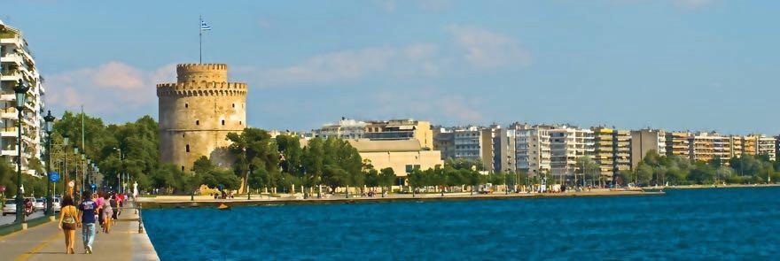
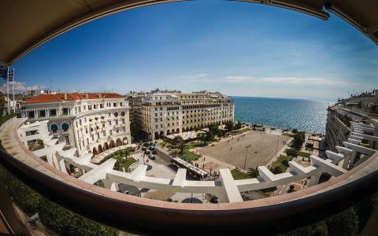

Thessaloniki
Study Destinations: Thessaloniki

THE CITY OF THESSALONIKI
Thessaloniki is the second largest city in Greece, a classical city full of Hellenistic, Roman and Byzantine monuments. It was founded by Cassander and named after the sister of Alexander the Great. Over the long centuries of its history, today’s capital of Northern Greece has been distinguished as a foundation of the Hellenistic world and as the twin capital of Byzantium after Constantinople. Thessaloniki has been called a city of imagination, a melting-pot of populations and peoples, a city of myths, with roots stretching back into pre-history, a cosmopolitan center close to the beautiful resorts of Halkidiki.
THE ARISTOTLE UNIVERSITY
The Aristotle University (www.auth.gr) is named after Aristotle, the great Greek philosopher and teacher of Alexander the Great. It is the largest University in the Balkans with 60,000 students, which help define the cities rich intellectual and social life.
THE UNIVERSITY OF MACEDONIA
The University of Macedonia (www.uom.gr) started in 1957 as a graduate industrial school. From 1990 have also eight fields of undergraduate studies. Its main goal is the University of Macedonia students, dynamically and effectively to participate in the new challenges of an international and ever more globalize market.
HOUSING
Students at Thessaloniki will be housed at rental apartments. Arrangements have been made for one meal daily (supper) and also lunch with a Paideia scholarship based on merit and need, during the school days for the entire semester.
COURSE OFFERINGS
For course offerings please see the course registration forms. The courses will be taught in English by regular professors within the premises of the Aristotle and Macedonia Universities.
ATTENDANCE is required for full credit. Students with unexcused absences will receive an incomplete.

6

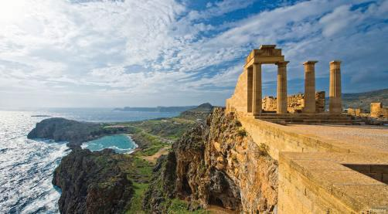
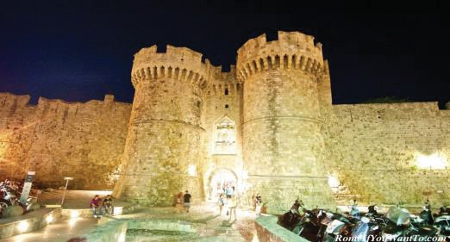
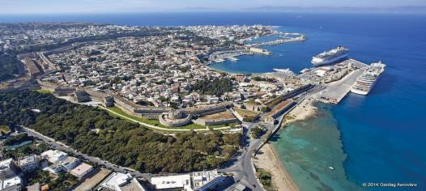

Rhodes
Study Destinations: Rhodes
Rhodes is the largest of the Dodecanese Islands. One of the most important events in Rhodes’ 4,000 years recorded history was the formation of a new city in 407 B.C. from the existing three city-states of: Kamiros, Lindos and Ialysos. In the Hellenistic period, Rhodes was one of the finest and most well organized cities of the known world. The city was
surrounded by impenetrable fortification, while the ships of Rhodes, roved throughout the Mediterranean Sea. Its streets were lined with temples, gymnasiums, theaters, and its city port entrance was adorned with the famous “Colossus of Rhodes”, one of the seven wonders of ancient world. Rhodes became one of the important centers of learning. Schools and academies of rhetoric and philosophy sprang up. Today, Rhodes is a vibrant cosmopolitan center attracting more tourists than any other Greek Island. In parallel to its crystal clear waters and beautiful beaches, the old city presents one of the most well preserved medieval castles.
THE UNIVERSITY OF AEGEAN

The University Of Aegean (UA) (www.aegean.gr) has been established on five islands of the Aegean Archipelago. It is a rapidly growing University, which helps define the Island’s rich intellectual and social life. Particular emphasis is placed on research with diverse research programs established on environmental science, education, business administration and computer science, along with strong academic
collaborations with European and Black Sea Universities. Most UA’s departments offer graduate level courses that lead to M. Sc. and Ph. D. degrees.
THE HELLENIC CENTER FOR MARINE RESEARCH

HCMR is the national laboratory of Greece for all aspects of marine research, physical oceanography, marine geology, wave prediction, coastal geomorphology, fisheries, aquaculture, marine biology, marine genetics and inland waters. HCMR operates the Poseidon system that provides real time forecasts for winds and waves in the Greek seas, through a network of deep ocean buoys. HCMR operates three oceanographic ships, one manned submarine and four remote operated vehicles. HCMR handles all search and recovery operations for the Hellenic Air Force and Navy. Also operates two aquariums in Heraklion and Rhodes.
All aquaculture production is a result of HCMR initiatives and research in Greece.

HOUSING

Students at Rhodes will be housed at the beautiful hotels. At the hotels there are 24 hours a day management at the front desk. Arrangements have been made for one meal daily (supper). Also lunch with a Paideia scholarship at University cafeteria based on merit and need, during the school days for the entire semester.

7

PAIDEIA 2023 WINTER INTERSESSION PROGRAMS IN GREECE
UPDATE: WINTER 2023

Winter intersession programs take place in Rhodes for credit and non credit courses.

The program includes visits to Archaeological sites, museums and monuments of Rhodes depending on student interest. The program includes a study tour at mainland Greece with excursions to museums, galleries, old churches, theaters, archaeological sites and monuments.

The study tour, depending on the weather conditions, will be in Athens, Epidauros, Nemea, Nafplion, Mycenae, Olympia, Patra, Nafpaktos, Delphi, Thermopylae, Dion, Vergina, Pella, Thessaloniki.

The courses are intensive for periods from 12/26/2022 to 1/15/2023.

Students in Rhodes will stay at hotels in walking distance from the classrooms. Students in Rhodes take dinner at the University of Aegean cafeteria, at the hotel, or at a local restaurant. Meals are seven days a week.

Paideia Scholarships: Paideia allocates scholarship grants in the range of $100-$500 to encourage and help winter intersession students for studies in Greece. Winter intersession students with a GPA of 3.7 or higher at the time of application automatically receive a $150 US reduction against their tuition fees.

Eligibility: It is preferable that students have a grade point average of 2.50 GPA.

Credits: 4 semester hours for Greek a language course and 3 semester hour for the class of Language & Culture of Greece. Transfer of credit is from Aegean Univ.

Cost: The program fee is $1,800 for one course without the study tour. With the study tour is $2,700. This includes orientation on December 27 in Greece, tuition, study abroad insurance coverage, housing, one meal daily (supper), land transportation, admission to museums and archaeological sites, cultural activities, local excursions, field trips and a study tour around Greece. If a student is interested for only the study tour the cost is $1,200. Part of this year program costs for each participant are defrayed through Paideia’s scholarship support. This scholarship is reflected in the program fee. This does not include the International Student Identity Card, and nonrefundable fees for application and registration to Paideia affiliated US Universities.

Additional estimated cost includes $1,200 for round-trip airfare from US to Athens and flights inside Greece, $700 for personal expenses and about $100 for textbooks. Applications can be obtained at your study abroad office or at:

Paideia Study Abroad Program in Greece 28 Dog Lane, P.O. Box 818,
Storrs, CT 06268-0818

Tel 860)906-8458.

Email: Paideia@snet.net

www.hellenicstudiespaideia.org

8

PAIDEIA PROGRAM COURCE REGISTRATION FORM
UPDATE: WINTE220221

Winter Intersession December 26, 2022 to January 15, 2023 Name
All students must sign up for 1 or 2 courses.

- MGRK 1101 ELEMENTARY MODERN GREEK I, Rhodes, Four Credits

- MGRK 1102 ELEMENTARY MODERN GREEK II, Rhodes, Four Credits

- MGRK 3299 THE LANGUAGE AND CULTURE OF GREECE

Study Tour around Greece for 9 days, December 26-January 5; 4 ARTH 3293 OFF-CAMPUS STUDIES IN ART HISTORY,
Study Tour around Greece for 9 days One Credit

EXCURSIONS

Paideia offers a number of excursions to discover Greece. These excursions are included in the program fee. Winter Intersession program includes a study tour around Greece for nine(9) days visiting archaeological sites, museums, old churches and monuments with a first meeting in Athens on December 27. An orientation meeting takes place in Athens upon arrival of all students. The study tour includes hotels, two meals daily (breakfast & supper) with entrance fees and passes. Land transportation from Athens during study tour is being covered from the program. Winter Intersession study tour starts in Athens and ends in Thessaloniki on January 4th. Students have the option to continue in Rhodes until January 15 for Language and Culture of Greece class.

CLASSES

Students who are interested for Modern Greek I, II during winter intersession stay in Athens only one night with the study tour students and continue in Rhodes late in the afternoon December 28.

Excursions are around the island with possible one day trip to the island of Symi (weather permitting

9

PAIDEIA 2023 SUMMER PROGRAMS IN GREECE
2018
UPDATE: SUMMER 20231

LANGUAGE, CULTURE, HISTORY, ARCHAEOLOGY, MARINE STUDIES

PAIDEIA 2023 summer programs are offered in Rhodes I n Classical @ Modern Greek, Culture, History, Archaeology, Art History, Environmental and Marine studies.

The program includes various summer concerts, visits to Archaeological sites and monuments of Greece depending on student interest and courses offered. The program includes a number of excursions to museums, galleries, churches and theaters. Some past destinations with guided field trips have included Kozani, Aiani, Pella, Vergina, Meteora, Nemea, Mycenae, Delphi, Athens, Thermopylae, Chaeronea, Epidauros, Nafplion, Sparta, Olympia, Patra, Corinth, Kos, Symi, Santorini.

Paideia Scholarships: Paideia allocates scholarship grants in the range of $100-$700 to encourage and help summer students for studies in Greece. Summer students with a GPA of 3.7 or higher at the time of application automatically receive a $150 US reduction against their tuition fees.

The courses are intensive for periods of three weeks between the dates: May 8 to May 28, May 29 to June 18, June 12 to July 2, June 27 to July 17, July 4 to July 25.

Students will live at a hotel or rental apartments in walking distance from the classrooms. Rhodes and Thessaloniki students take the evening meal at school cafeteria until June 30. Students in Aiani, Dion or Rhodes and other regions of Greece take dinner at a school cafeteria or restaurant seven days a week. Rhodes and Thessaloniki students during May and June have a second meal at the University cafeteria.

Eligibility: It is preferable that students have a grade point average of 2.5 GPA.

Credits: 4 semester hours for Greek language courses and 3 semester hours for history, archaeology and other courses.

Cost: The program fee is $2,000 for one course. For two the cost is $1,200 for the second course during the same period, which includes orientation, tuition, housing, meal, cultural activities, local excursions and field trips. For the class with a study tour around Greece the cost is $2,900. If a student is interested for only the study tour the cost is $1,500 Part of this year program costs for each participant are defrayed through Paideia’s scholarship support. This scholarship is reflected in the program fee. This does not include the International Student Identity Card, and a non refundable fees for application and registration through the University of Connecticut or other Paideia affiliated Universities.
Additional estimated costs include $1,500 for round-trip airfare, $40.00 study abroad insurance coverage per month, $1,000 for personal expenses and about $100 for textbooks. For more information and course outlines you can contact:

Paideia Study Abroad Programs in Greece Center for Hellenic Studies Paideia
28 Dog Lane, P.O. Box 818
Storrs, CT 06268-0818
Tel: (860)906-8458
Email: Paideia@snet.net www.hellenicstudiespaideia.org

10

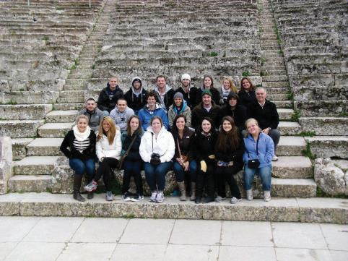
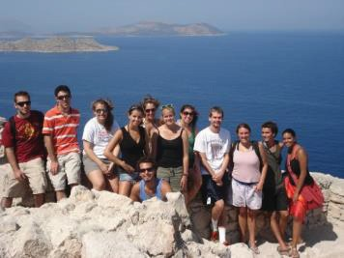
2022 - 2023 Academic Year
2017-2018

Courses
The course menu is rich in Language, History, Archeology, Business, the Arts, Culture, Political Science, and Marine Science.

Paideia reserves the right to cancel a course due to low enrollment, changing political or economic factors, unusual circumstances, or any other event which dramatically impact the nature of the course or the ability of the faculty to conduct such course.

Name
All students must sign up for 5, with a minimum of 4 three credit courses.
Communication:

Class Title | When It’s Offered | Credits | Check if Interested
Electronic Mass Media Technology | Spring/Fall | 3
Writing for Print | Spring/Fall | 3
Writing for Broadcast | Spring/Fall | 3
Talk, Interview, and Discussion Programs | Spring/Fall | 3
Risk Communication and Globalization of Risk | Spring/Fall | 3
Television and Entertainment | Spring/Fall | 3
Structure of Radio and Magazine Industry | Spring/Fall | 3
Public Relations and Communications | Spring/Fall | 3
Interviewing | Spring/Fall | 3
Mass Communication Systems | Spring/Fall | 3
Political Communication and Democracy | Spring/Fall | 3
Power, Journalism, and Political Communication in Film | Spring/Fall | 3
Multimedia Production (including Internet multimedia) | Spring/Fall | 3
Television Production II (including Web-TV) | Spring/Fall | 3
Computer Mediated Communication | Spring/Fall | 3
Business Communications | Spring/Fall | 3
Radio Production (including Web – Radio) | Spring/Fall | 3
Public Policy Making: government, inter-governmentalism | Spring/Fall | 3
Media Management | Spring/Fall | 3
Environmental Journalism in SE Europe | Spring/Fall | 3
News Sources and International News Organizations | Spring/Fall | 3
The Rise of Digital Genre: Online Newspapers | Spring/Fall | 3
Cultural and Creative Industries | Spring/Fall | 3
Travel, Journalism, Communication and Social Media | Spring/Fall | 3
Tourism and Media  The Language of Social Media and its Application | Spring/Fall Fall/Spring | 3  3

Architecture:

Class Title | When It’s Offered | Credits | Check if Interested
History of Architecture: Antiquity | Spring/Fall | 3
History of Architecture: Byzantium – Islam | Spring/Fall | 3
Restoration-Reuse of Historical Buildings (Methodology) | Spring/Fall | 3
Greek Design and Architecture | Spring/Fall | 3
Diachronic Approach to Greek Architecture | Spring/Fall | 3

Visual and Applied Arts:

Class Title | When It’s Offered | Credits | Check if Interested
Special Aspects of Digital Image – Internet I | Spring/Fall | 3
Special Aspects of Digital Image – Interactive Media I | Spring/Fall | 3
Special Aspects of Digital Image – Interactive Media II | Spring/Fall | 3
Drawing I | Spring/Fall | 3
Drawing II | Spring/Fall | 3
Elements of Sculpture | Spring/Fall | 3
Sculpture V | Spring/Fall | 3
Sculpture VI | Spring/Fall | 3
Elements of Digital Image I | Spring/Fall | 3
Elements of Digital Image II | Spring/Fall | 3
Painting I | Spring/Fall | 3
Painting II | Spring/Fall | 3
Painting III | Spring/Fall | 3
Painting IV | Spring/Fall | 3
Painting V | Spring/Fall | 3
Painting VI | Spring/Fall | 3
Engraving I | Spring/Fall | 3
Engraving II | Spring/Fall | 3
Engraving III | Spring/Fall | 3
Engraving IV | Spring/Fall | 3
Engraving V | Spring/Fall | 3
Engraving VI | Spring/Fall | 3
Engraving VII | Spring/Fall | 3
Engraving VIII | Spring/Fall | 3
Engraving IX | Spring/Fall | 3
Multimedia Productions | Spring/Fall | 3
Biology:

Class Title | When It’s Offered | Credits | Check if Interested
Lake and River Ecosystems | Spring/Fall | 3
Environmental Education and Awareness | Spring/Fall | 3
Internal Medicine Biomaterials Generic Engineering  Biochemistry- General  Practical Traning-Food/Biotechnology Human Anatomy | Spring/Fall Fall/Spring Fall/Spring Fall/Spring Fall/Spring Spring/Fall

Physics:

Class Title | When It’s Offered | Credits | Check if Interested
Physics IV (waves and optics) | Fall/Spring | 3
Atmospheric and Environmental Physics | Fall/Spring | 3
Optics laboratory | Fall/Spring | 3
Electronics | Fall/Spring | 3
Bioelectromagnetics | Fall/Spring | 3
History and Evolution of Concepts in Physics | Fall/Spring | 3
Physics of Metals | Fall/Spring | 3
Quantum Mechanics I | Fall/Spring | 3
Cormic Radiation | Fall/Spring | 3
Physics of Materials | Fall/Spring | 3
Computational Simulation Methods in the Physics of Condensed Phases and Complex Systems I | Fall/Spring | 3
Solid State Physics | Fall/Spring | 3
Magnetic Materials and Applications | Fall/Spring | 3
Nonlinear Dynamical Systems | Fall/Spring | 3
Digital Circuits | Fall/Spring | 3
Atmospheric Environment | Fall/Spring | 3
Electronic Circuits | Fall/Spring | 3
Physics of Nanostructures and Surfaces | Spring/Fall | 3
Solid State Physics II | Spring/Fall | 3
Radiation Physics and Applications of Radioisotopes | Spring/Fall | 3
Cosmology | Spring/Fall | 3
General Theory of Relativity | Spring/Fall | 3
Photonics and Applications | Spring/Fall | 3
Atmospheric Technology | Spring/Fall | 3
Global Environmental Changes Thermodynamics | Spring/Fall Spring/Fall | 3  3

Psychology:

Class Title | When It’s Offered | Credits | Check if Interested
Issues in Clinical Psychology and Neuropsychology | Fall/Spring | 3
Psychology in Education: Theory, Research, Applications | Fall/Spring | 3
Research Frontiers in Psychology | Spring/Fall | 3
Societal Issues in Psychology | Spring/Fall | 3

Informatics:

Class Title | When It’s Offered | Credits | Check if Interested
Human Computer Interaction Design | Spring/Fall | 3
Computer Music | Spring/Fall | 3
Mobile Device Interfaces 3D CAD and Optimization | Spring/Fall | 3

Economics:

Class Title | When It’s Offered | Credits | Check if Interested
Tourism Development | Fall/Spring | 3
Tourism and Media | Spring/Fall | 3

Political Science:

Class Title | When It’s Offered | Credits | Check if Interested
Sectoral Policies of the European Union | Fall/Spring | 3
European Union Politics and the Government | Spring/Fall | 3
Greece Today | Spring/Fall | 3

English Language and Literature:

Class Title | When It’s Offered | Credits | Check if Interested
All courses offered by the Department of Linguistics | Spring/Fall | 3
All courses offered by the Department of English Literature | Spring/Fall | 3
All courses offered by the Department of American Literature | Spring/Fall | 3
Drama | Spring/Fall | 3
Poetry | Spring/Fall | 3

Greek Language:

Class Title | When It’s Offered | Credits | Check if Interested
Elementary Modern Greek I | Spring/Fall | 4
Elementary Modern Greek II | Spring/Fall | 4
Intermediate Modern Greek I | Spring/Fall | 4
Intermediate Modern Greek II | Spring/Fall | 4

Name All students must sign up for 5, with a minimum of 4 three credit courses.
Business / Law / Economics:

Class Title | When It’s Offered | Credits | Check if Interested
Topics in Economic History of Greece | Spring/Fall | 3
Managerial Economics | Spring/Fall | 3
Financial Management | Spring/Fall | 3
Elements of European Community Law | Spring/Fall | 3
Business Law | Spring/Fall | 3
Business Law and Ethics | Spring/Fall | 3
Business Strategy | Spring/Fall | 3
European Union: Institutions and Politics | Spring/Fall | 3
European Union and Greek Corporations | Spring/Fall | 3
International Organizations and Law | Spring/Fall | 3
International Relations and Democratization in South East Europe | Spring/Fall | 3
European Union Economic Integration and Labor Market Institutions | Spring/Fall | 3
International Economic Law and Law of International Transactions | Spring/Fall | 3
The European Union and the United States of America: Comparing Economic and Social Institutions | Spring/Fall | 3
Labor Market Institutions and Human Resource Management in the European Union and the United States | Spring/Fall | 3
Money, Banking and Financial Markets | Spring/Fall | 3
Global Financial Management | Spring/Fall | 3
International Finance/Investments | Spring/Fall | 3
Principles of Economics | Spring/Fall | 3
Principles of Microeconomics and Macroeconomics | Spring/Fall | 3
Intermediate Microeconomics and Macroeconomics | Spring/Fall | 3
Introduction to Operations Management | Spring/Fall | 3
Productions and Operations Management | Spring/Fall | 3
Organizational Behavior | Spring/Fall | 3
International Business | Spring/Fall | 3
International Marketing | Spring/Fall | 3
Economics and Business in the Black Sea Region | Spring/Fall | 3
Economics and Business in the Balkan Region | Spring/Fall | 3
Consumer Behavior and Strategy | Spring/Fall | 3
Marketing Analysis and Decision Making | Spring/Fall | 3
Management and Organizational Behavior | Spring/Fall | 3
Marketing Analytics | Spring/Fall | 3
Global Marketing Strategy | Spring/Fall | 3
Global Marketing Management | Spring/Fall | 3
Political Science:
English Language and Literature:

Class Title | Offered | Credits | Check
Sectoral Policies of the European Union | Fall/Spring | 3
European Union Politics and the Government | Spring/Fall | 3
Greece Today | Spring/Fall | 3

Business / Law / Economics (Continued):

Class Title | When It’s  Offered | Credits | Check if  Interested
Branding and Product Strategy | Spring/Fall | 3
Tourism Marketing and Management | Spring/Fall | 3
Event Marketing | Spring/Fall | 3
Tourism and Hotel Industry | Spring/Fall | 3
Public Relations | Spring/Fall | 3

History:

Class Title | When It’s Offered | Credits | Check if Interested
History of Modern Greece | Spring/Fall | 3

Foreign Languages:

Class Title | When It’s Offered | Credits | Check if Interested
Elementary Modern Greek I | Spring/Fall | 4
Elementary Modern Greek II | Spring/Fall | 4
Intermediate Modern Greek I | Spring/Fall | 4
Intermediate Modern Greek II | Spring/Fall | 4
Elementary Russian | Spring/Fall | 3
Intermediate Russian | Spring/Fall | 3
Elementary Serbian | Spring/Fall | 3
Intermediate Serbian | Spring/Fall | 3
Elementary Armenian | Spring/Fall | 3
Intermediate Armenian | Spring/Fall | 3
Elementary Romanian | Spring/Fall | 3
Intermediate Romanian | Spring/Fall | 3
Elementary Bulgarian | Spring/Fall | 3
Intermediate Bulgarian | Spring/Fall | 3
Elementary Turkish | Spring/Fall | 3
Intermediate Turkish | Spring/Fall | 3
Elementary Hebrew | Spring/Fall | 3
Intermediate Hebrew | Spring/Fall | 3
Elementary Arabic | Spring/Fall | 3
Intermediate Arabic | Spring/Fall | 3

Computer Science:

Class Title | When It’s Offered | Credits | Check if Interested
Computer Networks and Security | Spring/Fall | 3

Regional Studies (Available Upon Request):

Class Title | When It’s Offered | Credits | Check if Interested
Classes available upon request from the Department of Balkan, Slavic, and Oriental Studies. Also for Economy,  Politics, History, and Literature of these countries. | Upon Request | 3

Name
All students must sign up for 5, with a minimum of 4 three credit courses.

Marine Biological Topics:

Class Title | When It’s  Offered | Credits | Check if  Interested
The Greek Environment | Spring/Fall | 3
Marine Ecology | Spring/Fall | 3
General Oceanography | Spring/Fall | 3
Marine Biology | Spring/Fall | 3
Introduction to Marine and Coastal Law | Spring/Fall | 3
Maritime History and Underwater Archaeology | Spring/Fall | 3
Global Ecopolitics | Spring/Fall | 3
Environmental Policy and Politics | Spring/Fall | 3
Environmental Resource Management | Spring/Fall | 3

History:

Class Title | When It’s Offered | Credits | Check if Interested
Study of Ancient Eastern Mediterranean | Spring/Fall | 3
Minoan and Mycenaean History and Archaeology | Spring/Fall | 3
History and Archaeology of Ancient Greece | Spring/Fall | 3
History and Archaeology of Byzantine Greece | Spring/Fall | 3
History of Modern Greece | Spring/Fall | 3
Rhodes of the Hellenistic Period History of Anthropological Theory  Archaeological Method and Theory | Spring/Fall Fall/Spring  Fall/Spring | 3  3  3

Art:

Class Title | When It’s Offered | Credits | Check if Interested
Early Chritian and Byzantine Art History | Spring/Fall | 3
Topics in Aegean Greek and Roman Art | Spring/Fall | 3
Ancient Greek Art: Vase Painting and Sculpture | Spring/Fall | 3
Off-Campus Studies in Art History | Spring/Fall | 1
Beginning Sculpture | Spring/Fall | 3
Beginning Ceramics | Spring/Fall | 3
Intermediate Sculpture | Spring/Fall | 3
Intermediate Ceramics | Spring/Fall | 3

Language Arts:

Class Title | When It’s Offered | Credits | Check if Interested
Modern Greek Literature | Spring/Fall | 3
Elementary Modern Greek I | Spring/Fall | 4
Elementary Modern Greek II | Spring/Fall | 4
Intermediate Modern Greek I | Spring/Fall | 4
Intermediate Modern Greek II | Spring/Fall | 4
Language and Culture of Greece | Spring/Fall | 3
Ancient Greek I | Spring/Fall | 3
Ancient Greek II | Spring/Fall | 3
Ancient Greek Mythology | Spring/Fall | 3
Law of Ancient Athens | Spring/Fall | 3
Ancient Greek Rhetoric | Spring/Fall | 3
Ancient Greek Theater I: Aeschylus – Sophocles | Spring/Fall | 3
Ancient Greek Theater II: Euripides – Aristophanes | Spring/Fall | 3
Judaic Language | Spring/Fall | 3
Turkish Language | Spring/Fall | 3
Arabic Language | Spring/Fall | 3
Other classes upon request from the Department of  Mediterranean Studies | Spring/Fall | 3

Psychology / Education:

Class Title | When It’s Offered | Credits | Check if Interested
Family Theory | Spring/Fall | 3
Introduction to Statistics | Spring/Fall | 4
Introduction to Psychology | Spring/Fall | 3
Developmental Psychology | Spring/Fall | 3
Developmental Deviations During Childhood | Spring/Fall | 3
Counseling Psychology | Spring/Fall | 3
Educational Psychology | Spring/Fall | 3
Education and New Technologies | Spring/Fall | 3
Technological and Didactical Innovations: Virtual Reality | Spring/Fall | 3

SUMMER CLASSES 2023

- Topics in Aegean Greek Art History (May 29 - June 18)

- Intermediate Painting(May 29- June 18)

- Modern Greek I, II, III (May 29- June 18)

- Ancient Greek Mythology(May 29 - June 18)

- The Law of Ancient Athens(May 29 - June 18)

- The Greek Theater as Social & Political Institution in the Mediterranean during Antiquity(May 29 - June 18).
- Language and Culture of Greece with study tour (May 21 - June 11)

- Off Campus Art History of Greece(one credit) with the study tour (May 21- May 30)

- Modern Greek classes I,II,III (June 19 - July 9)

- Advertising and Promotions (May 14- June 4).

PAIDEIA 2023 SPRING BREAK IN GREECE

CULTURE, HISTORY, ARCHAEOLOGY
PAIDEIA semester/year around programs are offered in Athens, Thessaloniki and Rhodes in collaboration with Aristotle University, University of Macedonia, University of Athens, University of Aegean, and National Center for Marine Research.
PAIDEIA summer and winter intersession programs are offered in Thessaloniki, Dion, Kozani, Sparta, Delphi, and Rhodes in Classical & Modern Greek, Culture, History, Art History, Archaeology and Marine Studies.
The Spring Break Program:
Includes various cultural activities, visits to Archaeological sites, museums, old Byzantine monasteries and monuments of Greece. The program includes excursions to museums, galleries, churches and
theaters. Some past destinations with guided field trips have included Rhodes, Aiani, Vergina, Isthmus, Meteora, Dion, Delphi, Athens, Thermopylae, Epidauros, Nafplion, Sparta, Mystras, Monemvasia, Olympia, Patra, Dodona, Metsovo, Ioannina, Nemea, Mycenae, Pella, Amphipolis, Thessaloniki.
Itinerary:
Departure from US is0on Friday, March 11 to Athens, Greece. Study tour in mainland Greece from March 11 to March 19. Departure from Athens to US on March 19. End of program.
Housing:
Students will stay at hotels in different cities.
Eligibility:
Full time US Colleges and Universities students.
Cost:
The program fee for College students is $3,000. This includes R/T air flight, orientation, tuition, housing, land transportation with a private bus, two meals daily (breakfast and diner), cultural activities, excursions with a study tour in mainland Greece. Part of this year program costs for each participant are defrayed through Paideia’s scholarship support.
Additional estimated costs:
$40.00 study abroad insurance coverage; $500 for personal expenses.

Applications can be obtained at:
Center for Hellenic Studies Paideia:28 Dog Lane, P.O. Box 818, Storrs, CT 06268
Tel (860)906-8458
Email: Paideia@snet.net www.hellenicstudiespaideia.org

PAIDEIA STUDY ABROAD PROGRAMS IN GREECE 2023 CULTURAL SPRING BREAK IN GREECE
Complete all sections bellow:
Full Name: Address: City: State: Zip:
Telephone: ( ) Age: Date of Birth: _
Name of School-College - University: Credits completed: GPA Departure City or Airport: Date of Departure: March 10
E-mail address:
Parent/Guardian’s name:

Telephone: ( ) Fax: ( ) Email address:

Contact in Case of Emergency:

Contact’s phone #: Insurance carrier: Policy Number:

Student’s Signature

Parent/Guardian Signature for students under 21 years of age.

Complete and return the form by February 22. 2023 to: Center for Hellenic Studies Paideia

28 Dog Lane, Storrs, CT 06268-0818. Telephone/Fax: (860)906-8458.
E-mail: Paideia@snet.net; www.hellenicstudiespaideia.org

HIGH SCHOOL LANGUAGE, CULTURE, HISTORY, MYTHOLOGY

PAIDEIA College level semester/summer/winter intersession programs are offered in Athens, Thessaloniki and Rhodes in collaboration with Aristotle University, University of Macedonia, University of Athens, University of Aegean, and NCMR.
PAIDEIA 2022 High school summer programs are offered in Rhodes in Ancient @ Modern Greek, Culture, Mythology and History The program includes various cultural activities, visits to Archaeological sites and monuments of Greece depending on student interest and courses offered. The program includes a number of excursions to museums, galleries, churches and theaters.
Some past destinations with guided field trips have included Kozani, Aiani, Vergina, Meteora, Volos, Delphi, Athens, Nemea, Mycenae, Thermopylae, Orhomenos, Epidauros, Nafplion, Sparta, Olympia, Patra, Korinthos, Kos, Symi, Patmos.
The courses are intensive for periods of three weeks between the dates: June 17 to July 7 and June 24 to July 14, July 1 and July 21.
Students will live at rental apartments in walking distance from the classrooms. Students in Rhodes take dinner at a restaurant seven days a week.
Eligibility: It is preferable that students have a grade point average of 2.5 GPA.
Credits: College credit for Modern Greek classes for juniors and seniors. Cost: The program fee is $2,000 for one course. For two or more the cost is $1,200 per course during the same period, which includes orientation, tuition, housing, meal, cultural activities, local excursions and field trips. For the three week class with a study tour around Greece the cost is $2,900. Part of this year program costs for each participant are defrayed through Paideia’s scholarship support. This scholarship is reflected in the program fee. For the eight days class Off Campus Art History with the study tour is
$900. During the study tour students have two meals daily (breakfast and supper).
Additional estimated costs include $1,500 for round-trip airfare, $40.00 study abroad insurance coverage per month, $700 for personal expenses and about $100 for textbooks.

Applications can be obtained at:
Center for Hellenic Studies Paideia28 Dog lane, P.O. BOX 818, Storrs, CT 06268
Tel (860)906-8458 cell Email: paideia@snet.net
www: www.hellenicstudiespaideia.org

HIGH SCHOOL COURCE REGISTRATION FORM – SUMMER 2023

Name

All students must sign for 1 or 2 courses.

1.
ELEMENTARY MODERN GREEK I
Rhodes June 17 to July 7.
Rhodes July 8 to July 28.

2.
ELEMENTARY MODERN GREEK II
Rhodes June 17 to July 7.
Rhodes July 8 to July 28.

3.
THE LANGUAGE AND CULTURE OF GREECE
Rhodes with a Study Tour around Greece 7/5 – 7/23.

EDUCATOR GRANTS for k-12
HELLENIC STUDIES
PAIDEIA EDUCATOR ENRICHMENT GRANTS DESCRIPTION

Paideia Educator Grants will provide educators an opportunity to undertake an intensive study program, Paideia Educator Enrichment Program for Hellenic Studies K-12, in Greece. This study program will provide a substantive intellectual experience which is aimed at invigorating ancient and contemporary Hellenic studies in
the nation’s schools. This program is undertaken in collaboration with the Paideia Study Abroad Programs at
the University of Aegean, Rhodes, Greece. The study program will:
- survey Hellenic history, archeology, arts and literature with visits to ancient sites ranging from the Neolithic to the Byzantine periods

- offer opportunities to observe the topography, natural resources and industries of modern Greece,

- lectures by professors from US and Greek Universities,

- participation in Greek cultural activities.

Educator Grants are offered to administrators, superintendents and teachers to provide them with the opportunity to:

- travel and study in Greece for up to 21 days,

- apply their learning to the development of a portfolio consisting of a curriculum and resource kit
. ▪ use the portfolio with students the year following their study, Grants will be awarded to educators by the Hellenic Society Paideia upon:

- demonstration of full time educational employment,

- submission of a portfolio proposal,

Awards for the Paideia Educator Enrichment Grant will be made on a competitive basis from among a pool of candidates generated throughout the United States.

HELLENIC SOCIETY PAIDEIA
The Hellenic Society Paideia, established in 1977, is dedicated to promoting Hellenic Studies. It promotes Hellenic learning and knowledge of civilization, culture and language. It supports and assists individuals, organizations and higher education institutions with resources, research and guidance in the preservation and promotion of the Greek language, culture, education, art, history, music and religion.

GRANT REQUIREMENTS
The Paideia Educator Enrichment Program for Greek Studies is open to all full-time educators K-12.
- In order to be eligible for a Paideia Educator Grant, the candidates:
  - must have a full-time position as a teacher, administrator or superintendent in a public or private educational institution or a school district.

  - must have held a position during the prior year and must hold one in the following year at their present institution or school district

  - must submit a letter from their educational institution or district demonstrating:

    - they hold such position and an interest to offer the curriculum the following year.
    - areas of study may include social sciences, business, environment, sciences, mathematics, humanities, foreign languages, journalism and fine arts with a unique relevant to Greece.
- Applicants who are accepted are required to participate in all Paideia Educator Enrichment Program activities in Greece. They also must allow the Center for Hellenic Studies to survey and/or observe the implementation of the curriculum for evaluative purposes in the future.

- PORTFOLIO PROPOSAL

This requirement may be met by the development of a curriculum in some aspect of Hellenic Studies shall include:
- Grade level: K-12
- Time: a year, a semester, a month, a week
- When: school year following the study program
- Where: candidate’s school district or school
- Type: new curriculum, redesign of an existing curriculum or enrichment of a current curriculum

- Resource Kit
  - The development of materials that will be used by the candidate with the curriculum and/or may be used by other educators.
  - It must consist of two categories of materials: material from the US and from Greece.
- Evaluation Reports
- of the study program (before leaving Greece)
- of the portfolio outcomes (in US)
  - evaluation of the results of the curriculum

  - submitted to Center for Hellenic Studies Paideia

- PORTFOLIO COMPLETION

Time will be provided during the end of the study program to work on the portfolio in Greece. The portfolio must be either completed or developed in rough draft in Greece. Candidates must complete their portfolio and submit it to the Center of Hellenic Studies PAIDEIA by September 30th, 2017. Portfolios will be evaluated and participants will receive feedback.

GRANT
The program cost is $2,000.00. The applicant may request a Grant of up to $ 1,000.00 US dollars to be applied towards the program. The program includes hotels, food (dinner), admission fees to museums/ historic sites, the use of facilities and transportation within Greece during the 21 days. The program cost does not include air
travel to and within Greece. A family member may accompany the recipient but they will have a different fee schedule.

RESTRICTIONS
Provisions are not made for air travel. Provisions are not made for any released time stipends or for overhead costs to the institution or district employing the educator. The Grant is not available two consecutive years to the same recipient. The Grant does not apply to family members of the applicant. The applicant may request that family members attend; their acceptance will be determined by space availability.
APPLICATION IS DUE. DATE: May 10th, 2023

CLASSICAL GREEK I

Ancient Greek I introduces students to elementary aspects of the ancient Greek language: phonetics, listening, reading and writing comprehension. Students will learn essential vocabulary while developing an understanding of the grammar and structure of the language. At the same time, they will become familiar with some cultural points of the country, its mythology, literature and history. During the second half of the semester the students will also be introduced to selected original texts.
CLASSICAL GREEK II

Ancient Greek II introduces students to elementary aspects of the ancient Greek language: listening, reading and writing comprehension. Students will learn essential vocabulary while developing an understanding of the grammar and structure of the language. At the same time, they will become familiar with some cultural points of the country, its mythology, literature and history. Throughout the semester the students will also be introduced to selected original texts from the
Histories of Herodotus
INTRODUCTION TO ANCIENT GREEK MYTHOLOGY

Myth is a complex cultural phenomenon that can be approached from a number of viewpoints. In general, myth is a narrative that describes and portrays in symbolic language the origin of the basic elements and assumptions of a culture. Mythic narrative relates, for example, how the world began, how humans and animals were created, and how certain customs, gestures, or forms of human activities originated. Almost all cultures possess or at one time possessed and lived in terms of myths. Myths differ from fairy tales in that they refer to a time that is different from ordinary time (see Folktales). The time sequence of myth is extraordinary—an “other” time—the time before the conventional world came into being. Because myths refer to an extraordinary time and place and to gods and other supernatural beings and processes, they have usually been seen as aspects of religion. Because of the all-encompassing nature of myth, however, it can illuminate many aspects of individual and cultural life.
ELEMENTARY MODERN GREEK I

Greek 101 introduces students to all aspects of the Greek language: listening comprehension, speaking, reading and writing. Students will learn the vocabulary that is necessary for daily communication while developing an understanding of the grammar and structure of the language. At the same time they will become familiar with some cultural points of the country (greeting, ordering food etc).
ELEMENTARY MODERN GREEK II

With Elementary Modern Greek II the students can further improve their listening, speaking and reading skills, and learn more vocabulary. They listen to interviews and talks and read longer texts taken from authentic sources. They participate in a range of activities such as discussions, meetings and talks (communicative context) in order to become more effective and confident communicators in Greek. They can also review and expand their range of expressions for functions such as giving opinions, agreeing, giving advice and suggestions, making requests and offers.
INTERMEDIATE MODERN GREEK I

At level 3 students are given the opportunity to revise basic structures and concepts at the same time that new structures at more advanced level are introduced. New grammatical and syntactic structures are consolidated through the reading of more advanced texts from authentic sources such as the media, literary excerpts, professional and scientific articles from disciplines such as psychology, sociology, literature and language. Language learning is promoted by the direct use of language in both the spoken and written modes through specific activities designed or provided by the instructor.
MODERN GREEK LITERATURE

In the first part of the course specific references will be made to the distinction between orality and literacy. The development and language of Modern Greek literature will occupy the following lessons. The second part of the course will be based on the study of selected Greek poetry and prose, with emphasis on the idea of continuity in Modern Greek literature and modernism.

THE LANGUAGE AND CULTURE OF GREECE

This course is divided into two parts: First the Language of Greece and second the Culture of Greece. It is a survey course covering the history of the Hellenic language from its very origin to the present. Introduces the student to the art and architecture of Greece, to folk beliefs, tales and songs, which are recognizable derivations from the Greek Mythology. Discovers the Greek Philoxenia (quest friendship) from the Homeric Age to the present, religious beliefs, ceremonies and culture, the land and the people of Greece
The GREEK THEATER

Modern Greek Studies course covering The Greek Theater is a survey course from its very origin to the present. The student is introduced to the history and the development of an ancient Greek theater. The student discovers the original religious use and the evolution of the art of acting in an ancient theater. The student discovers that the history of the Greek theater in classical times is the history of the development of a religious idea into a national, literary, and artistic event. Explore the uses of a Greek Theater in a campus of a today American University.
ANCIENT GREEK THEATER I

Ancient Greek Theater I introduces students to elementary aspects of the Ancient Greek Theater: origins, space, audience, actors, the poets. Emphasis is given to the political background of Tragedy and Comedy. The students will study selected plays by Aeschylus and Sophocles in translation.
ANCIENT GREEK THEATER II

Ancient Greek Theater II focuses on the work of Euripides and Aristophanes. Emphasis is given to the political background of Tragedy and Comedy. The students will study selected plays by Euripides and Aristophanes in translation.
ANCIENT GREEK RHETORIC

The course introduces the students to the origins of Greek rhetoric. Students will be introduced to the concept of rhetoric as it appears in Homer, to the development of the sophist movement and the acme of rhetoric in the classical period.
Texts will be given in translation by the tutor.
EARLY CHRISTIAN AND BYZANTINE ART HISTORY

The course is a survey of Byzantine Art in its historical evolution and its forms as they expressed themselves: architecture, wall paintings, mosaics, icons, manuscripts etc. The course also investigates the special relationship of church and state in the Byzantine Empire. Such a relationship had a major influence in the development of Byzantine art, the clearest and most eloquent expression of Byzantine culture and civilization.
TOPICS IN AEGEAN GREEK ART HISTORY

This in an introduction to the Art History of mainland Greece, Crete, Cycladic and all Aegean Islands The class covers Minoan, Helladic & Cycladic, Mycenaean, Geometric, Archaic, 5th and 4th Century Classical, and Hellenistic Art. Ancient Aegean Culture has a particularly important place within the European History and Art History from 3,300 BC because of its profound links to the origins of European Civilization. Paintings, pottery of objects made from gold, silver and ivory, carved reliefs, textiles and architecture are discussed at this class. The students learn the many different functions that this vast range of arts and artifacts served within the cultural and social context of the Eastern Mediterranean for more than 3,000 years.
INTERMEDIATE PAINTING

Further develop foundation of painting: materials, techniques, form, space, organization, composition, color. Explore individual intuition and vision. Emphasis on visual form and principles rather than subject matter
BEGINNING SCULPTURE

Introduction to sculpture, three-dimensional thinking and vocabulary Students learn techniques such as, additive and reductive methods, mold making, found object construction, etc. Presentation of correct tool usage and safety issues. Studio practice, research, class discussions, slide lectures, field trips, and critique.

INTERMEDIATE SCULPTURE: MIXED MEDIA

Concentrates on mixed media processes and the figure Students learn a wide range of processes and formats such as: cold casting (resigns, plaster, construction, found object, wood, stone; installation, etc)
BEGINNING CERAMICS

Assigned projects to develop basic forming and glazing skills, an understanding of visual form, and creative problem solving
INTERMEDIATE CERAMICS: HIGH FIRE AND LOW FIRE

Assigned projects emphasize visual expression and further develop forming and glazing skills associated with thrown forms and stoneware reduction glazes.
Ancient Greek Art: Vase painting and Sculpture"

The course will focus on ancient Greek Art from the Early Iron Age (ca. 1100 B.C.) to the end of the Classical Period (ca. 330/20 B.C.) with particular reference to pottery, vase painting and sculpture.
OFF-CAMPUS STUDIES OF ART HISTORY

This is a one credit class. There are places you will visit either on the scheduled fieldtrips during the semester and/or during the week-long study tour to archaeological sites, museums, monuments, old churches, collections.
History of the Minoan and Mycenaean Period

The course is a historical survey of Pre-Hellenic and early Hellenic history with a concentration to the Minoan and the Mycenaean civilizations. We will study phenomena such as the rise of the city states, the political structure of the Minoan and Mycenaean state, their architecture, society, religion, economy and burial rites. We will follow the historical evolution of the Mycenaean civilization toits zenith. We will study the Mycenaean presence outside Greece to the days of the Trojan War and Homer. The course will end with the final decline of the Mycenaean civilization and the so called “Dark Ages” of ancient Greek history.
Study of Ancient Eastern Mediterranean

The course is a study of the environmental changes, cultural characteristics, emergence and decline of cultures and populations, catastrophic phenomena and their impact in the decline or migration of populations, namely earthquakes, floods, volcano explosions, pests, extraterrestrial impacts, meteorites, comet impacts, etc. in the region of the Mediterranean through antiquity. Special themes cover the lost Atlantis, the Thera volcano catastrophe, the Minoan and Mycenaean civilization collapse, archaic-geology landscapes and ancient civilizations, the ancient Eliki, the Argolid cases, the Trojan War and the Scamandros landscapes, etc.
HISTORY AND ARCHAEOLOGY OF ANCIENT GREECE

The aim of this course is to familiarize the students with the basic outline of the history of Greece from the archaic period until the rise of democracy. More specifically, the course will deal with the factors that enabled and assisted the crystallization of the democratic constitution in Greece.

The classes will be held in the form of lectures. However, dialogue with the lecturer is welcome and encouraged. There will also be the chance to use CD- ROMs, Videos and other facilities. The geographical setting: the situation of Greece in the Eastern Mediterranean and the main features of its landscape.

The beginning of Classical Greek culture: The Geometric Period (10th to 8th century BC). The first expansion of the Greeks and the creation of a monumental Greek art: The Orientalizing and Archaic periods (7th to 6th century BC).

HISTORY AND ARCHAEOLOGY OF ANCIENT MACEDONIA

A general introduction to the history and archaeology of Ancient Greece with a specific interest in the region of Macedonia The students stay at the area of Dion and Aiani. During their stay, they will take responsibilities concerning digging procedures and will attend seminars concerning the study of the archaeological material and its interpretation.

The program is designed to provide a basic introduction to field Museum techniques at the important sites of Dion and Aiani in North Western Greece, within the context of ancient Macedonian history. Guided field trips from Dion and Aiani, will include visits to Vergina, Pella, Kozani, and Thessaloniki. Except on field trip days, students will spend Monday to Friday from 9.00 am to 1.30 pm at the classroom/museum and at the neighboring archaeological sites. Selected readings,
e.g. from M. Joukowski: A complete manual of Field Archaeology, N.G.L. Hammond: The Miracle that was Macedonia, etc. will be assigned. There will be several sort tests.

Rhodes of the Hellenistic Period

The visitor of the island of Rhodes today will be surprised at the weight that is given to the image of Rhodes during the Byzantine and medieval era’s. The impressive remains of Rhodes from those periods, still alive in the medieval town (The Old Town, as the locals know it) aid the cultivation of this interest. However, the acme of Rhodes was during the Hellenistic period (during the reign and after the death of Alexander the Great). The aim of this course is to introduce the students to the illustrious military, political and cultural supremacy of Hellenistic Rhodes.

HISTORY OF THE HELLENISTIC PERIOD

The Hellenistic period is conventionally said to extend from the death of Alexander Great in 323 B.C. to the death of Cleopatra VII of Egypt in 30 B.C. The beginning of this story is marked by Alexander's successful invasion of the Persian Empire and its end by the division of the Near and Middle East between Rome and the new Iranian-ruled kingdom of Parthia. For much of the intervening three hundred years the territory of the former Persian Empire was dominated by a series of Macedonian-ruled kingdoms in which Greeks and Greek culture enjoyed unprecedented pre-eminence. Art and literature flourished, the foundations of Western literary scholarship were laid, and Greek scientists formulated ideas of theories that would remain fundamental to work in a variety of fields until the Renaissance.
HISTORY AND ARCHAEOLOGY OF BYZANTINE GREECE

This is a general introduction to the history and archaeology of Byzantine Greece. It covers the geographic area of the Eastern Mediterranean from the fourth to the fifteenth century AD. The course follows the history of the Eastern Roman Empire and its interaction with its surrounding area, Italy, North Africa and the Eastern Europe. Deals with the History of the Empire during the following periods: From the founding of Constantinople at 324 AD, to the outbreak of the Iconoclastic Debate c. 720 AD. This course covers from the end of the debate at 843 to the fall of Constantinople, 1204 to the crusaders of the Fourth Crusade. From the recapture of Constantinople by the Greeks, 1264 to its fall to the Ottoman Turks in 1453 In the course are examined the social and economic conditions of the Byzantine State, its relations with neighboring states and peoples and the cultural and religious events inside the State. Also examines the artistic material production of the Byzantine Empire.
MARITIME HISTORY AND UNDERWATER ARCHAEOLOGY (only in May)
The course provides a general introduction to the field of Underwater Archaeology, conveying what archaeological investigation seeks to accomplish, the ethics of archaeological investigation, and general practical principles of preliminary archaeological work underwater. The course introduces students to the material aspects of archaeology in the underwater environment, the changing technology of ship-building, submerged harbors, drowned cities, underwater cultural heritage management and archaeological museum displays. Archaeological evidence from the Mediterranean will be used to examine subjects as technological change, international trade, culture and seafaring sub- cultures.
HISTORY OF MODERN GREECE

The course is designed primarily for the needs of English speaking foreign university students with no knowledge of Modern Greek History. It aims to present the main aspects of the history and society of Greece since the beginning of the nineteenth century, concentrating primarily on political developments.

THE LAW OF ANCIENT ATHENS

This course surveys the legal philosophy, legal institutions, and laws of the great classical civilization of ancient Athens. Ancient accounts and literature provide the basis for a wide perspective of both substantive and procedural laws. In addition to traditional legal sources, readings also include selections based on a variety of ancient Greek authors, including Homer, Hesiod, Sophocles, Plato, Aristotle, and the Comedian Aristophanes. The course will address how social, religious, cultural, and political forces helped to shape ancient Athenian law. Students will also consider how ancient Greek concepts of law and justice compare with modern American law.
INTRODUCTION TO MARINE AND COASTAL LAW

Basic principles of International maritime and coastal law. An integration of coastal zone, outer continental shelf, fisheries, marine pollution, and admiralty laws This course deal with the legal framework of shipping in general, safety at sea, construction of ships, master and crew, marine pollution, unexpected events during the sea voyage, shipping activities.
Also, emphasis is given to the famous RhodianLaw of the Sea (ΝόμοςΡοδίων Ναυτικός -LexRhodia de iactu), one of the
most important sources of Maritime Law of all time and an academically sine qua non in the chain of the history of Maritime Law, mare liberum and mare clausum. The course follows a narrative concerning important elements of the legal governing framework of shipping from the Ancient times, to modern Greek Maritime Law, the Shipping Law of the
European Community and the United Nations. Basic principles of International marine and coastal law. An integration of coastal zone, outer continental shelf, fisheries, marine pollution, and admiralty laws
Family Theory

The course aims at offering a presentation of the major theoretical underpinnings of the current family therapy schools. The course is divided in three thematic areas:
. a) Historical account of the family therapy theories. This part refers to the factors that that led social scientists to
intensive research on family.
. b) Presentation of the underpinnings of General systems theory as the theoretical frame of all schools of family therapy.
. c) Presentation of the theoretical underpinnings of the basic schools of family therapy: Communication school of Palo
Alto, Minutchin’s Structural school, Bowenean School and the latest inspired by social constructivism.
Analysis of family interaction will be presented through the projection of video tapes. Discussion groups will be organized after each projection.
General Psychology

The course offers a complete and contemporary summary of the facts and principles essential to an understanding of psychology. It embraces biological, cognitive, developmental, social-psychological and clinical paradigms which will help the student to understand and to think of the field of psychology both as a product and a process. It follows a systems approach in covering the various aspects of behavior and experience and presents psychology as both a science and a profession.
Developmental Psychology

The course examines the developmental changes that take place in the individual from conception through adolescence. It covers all aspects of the developing individual from physical and neural development to social and cognitive development and how these kinds of development complement each other. The course emphasizes the determinants of human growth and development that is the identification of determining factors that lead to changes in behavior and abilities, individual differences and deviant behavior such as mental deficiency, drug addiction and delinquency.
EDUCATIONAL PSYCHOLOGY

The course examines the primary issues and problems in educational psychology. It is designed to introduce psychological principles theories and methodologies to issues of teaching and learning in schools. It includes topics related to development, cognition, behavior, emotion, culture and environment. The focus of the course is to support how educators can apply the major theories to become better teachers and learners.

COUNSELING PSYCHOLOGY

The educator, besides his/her teaching role, tries to facilitate growth and development to his/her students in many ways, such as help them acquire certain basic or more complex skills, help them work through traumatic events etc. The course will introduce the students to various schools of thought (individual therapy, person centered, existential, behavior therapy etc.), to the stages of counseling (the initial session, the facilitative relationship, goal identification and determination of counseling procedures, termination and follow up). Special emphasis will be given to educational counseling and the counseling procedures and/or strategies that be applied in a school setting.
DEVELOPMENTAL DEVIATIONS: MENTAL RETARDATION AND PSYCHOPATHOLOGY DURING CHILDHOOD

The course reviews the historical development of the institution of special education in Greece. The etiology and the symptoms of developmental dyslexia, attention deficit/hyperactivity disorders and other disorders of child psychopathology are examined. Special emphasis is given to the appropriate educational interventions for these disorders. The special role of the family and of the school, in the prevention of various learning and behavioral problems is pointed out.
MEDICAL TERMINOLOGY

Medical Terminology is the study of words that pertain to body systems, anatomy, physiology, medical processes and procedures and a variety of diseases. It provides specialized language for the health care team, enabling health care workers to communicate in an accurate, articulate and concise manner. This course is designed to give the students a comprehensive knowledge of word construction, definition and use of terms related to all areas of medical science. The course includes but is not limited to terms related to anatomy of the human body, functions of health and disease, and the use of language in processing medical/dental records and claim forms.
MULTIMEDIA AND VIRTUAL LEARNING ENVIRONMENTS

New technological innovations gradually get incorporated in everyday educational practice and the future educator will certainly be asked to use a number of them during his teaching. The rapidly increasing capabilities of computers and their diminishing price, makes such innovations affordable to the educational community hitherto inaccessible to the average user. Focusing in future developments, the weight of the course falls not on technologies that are already well accepted, but in cutting-edge technologies that are expected to play an important role in the coming years, such as the 3D educational games, which are the subject of this course. Their role, as well as the role of games in general, is important in the process of knowledge acquisition, because this is done with a pleasant way for the learner. Software tools appeared that allow the development of educational games easily, quickly and with a level of quality comparable to professional applications. So, the course is an excellent opportunity for students to get acquainted in the process of developing 3D educational games.
TECHNOLOGICAL AND DIDACTICAL INNOVATIONS: VIRTUAL REALITY

The course examines how advanced ICT applications are used in the educational process. Specifically, it deals with 3D graphics, multiuser virtual environments and with the educational uses of Virtual Reality. Virtual Reality is a technological development that significantly affects the ways we can enhance the learning process. The syllabus aims in the development of an in-depth understanding in the ways this can be achieved. The subject is approached both theoretically and practically. The major learning theories are analyzed, various types of software for the development of 3D applications is presented and examples of 3D educational applications are given. In the practical part, by using a relatively simple to use software, students have the opportunity to gain hands-on experiences while developing simple Virtual Reality educational applications.
GLOBAL ECO-POLITICS

This course aims to provide a comprehensive account of the main environmental discourses that influence the contemporary global politics of the environment. This course focuses on the international politics of global pollution, marine pollution, atmospheric pollution, tropical deforestation, and conservation.

ENVIRONMENTAL RESOURCE MANAGEMENT

The course on Environmental Resource Management is a series of seminar sessions aiming to address specific fundamental issues around Management of Natural Resources, Sustainable Development and Ecological Hazards. The course will be carried out in ten sessions. Environment, sustainability, the role of organizations, planning and managing resources and the environment, dealing with disasters, water, soil, air and finally energy are some of the important concepts that will be discussed within these sessions. There will also be reference on management and research generally. No previous knowledge around the topic is required, but if there is it will be taken into consideration. The sessions will involve mainly discussion around the topics under investigation.
ENVIRONMENTAL ANALYSIS AND POLICY IN COASTAL MANAGEMENT

The coastal zone is (i) a series of interacting sub-systems with uncertain boundaries (ii) a system with complex and poorly understood response to external forcing such as global sea level rise, and (iii) a system which is increasingly affected by anthropogenic use and management. Effective management of the coast therefore requires integration, development and application of knowledge from a wide range of disciplines including coastal scientists, ecologists, and socio-economicists.

This course introduces students to the coastal environment with particular emphasis on the understanding of how coast “works” and how anthropogenic activities affect the system. Finally it provides an introduction to coastal zone management in the context of environmental policy and natural resource management, with relevant test cases from the Mediterranean region.
Marine Ecology

To give an elementary background on marine life and marine processes. There is growing awareness of the society about the marine environment since it has been understood that the sea is a source of food, reservoir of minerals, the major oxygen suppliers, climate regulator and the ultimate dumping ground of human waste materials. This is why topics such as fisheries, Mari culture, pollution and mineral resources are included. Topics of general interest that is global warming, sea level change and marine law are also treated very briefly.
General Oceanography

This is a one-semester college-level introductory course in general oceanography. It covers the essentials of the four basic disciplines: physics, chemistry, biology and geology. It also introduces into the concept of the multidisciplinary approach to the marine environment through the special topics and one example of a case study.
THE GREEK ENVIRONMENT: major physical and biotic features

This course offers an overview to the major features of the Greek environment, as part of the Mediterranean environment. It will include aspects of geography and geology, vegetation, flora and fauna of terrestrial, marine, and wetland habitats, the relation of biotic with cultural elements, and an overview of the protected areas of the country. Introduces the student on Greek Flora; Phytoplankton in Lakes, Reservoirs and Coastal Sea in Greece; Water Quality in Greece; The Biodiversity in Greece
INTRODUCTION TO MARINE BIOLOGY

This course will provide you with the skills and knowledge to participate in, and contribute to, our deepening understanding of the various fields of scientific investigation which constitute marine biology at the beginning of the 21st century. Central to this course is the observational and experimental study of selected aspects of the ecology, physiology and evolution of marine organisms. Through an introduction to history of the Oceanography, physical and chemical properties of the sea water (Physical Oceanography), we will deepen into classification of the marine environment in primary and secondary producers (Biological Oceanography), to zoogeography, benthos, biodiversity and the shore environment (Marine Ecology), to other aspects of biology such as nutrition, excretion respiration osmotic regulation (Marine Biology of organisms) and end with management issues. This requires application of various approaches ranging from lectures, to field measurements and laboratory work.

Though a combination of lectures, field trips and lab work the course shall give knowledge of the sea as a habitat together with its organisms and give an insight at, and understanding for, how sea resources can be used in a sustainable way.

Writing for Print

Lectures, analyses and classroom activities and/or tasks are based on authentic data from American and British newspapers and focus on the following: Language varieties, newspaper language, the AP Stylebook
- News and feature story writing.
- Journalistic guidelines and techniques in relation to story structure(s), writing style(s), news values/criteria; cohesive devices, coherence.
. • Writing for Broadcast WRITING FOR BROADCAST Lectures, analyses and classroom activities/tasks are based on authentic data from local, network and satellite American and British channels and focus on the following:
  - News values/criteria; characteristics of broadcast news and feature story writing.
  - Story structure(s).
  - Tense, aspect, voice and lexical selections and their relation to the characteristics of immediacy, timeliness, directness; the role of cohesion and coherence.
  - Journalistic guidelines, conventions and techniques related to copy writing style.
  - Elements of phonology useful to anchoring. Interviewing: Writing Personality Profiles for the Print Media Lectures, analyses and classroom activities and/or tasks are based on authentic data from American and British newspapers and magazines and focus on the following:
  - Journalistic guidelines and techniques related to interviewing.
  - Linguistic, paralinguistic and extra-linguistic elements contributing to the establishment and maintenance of rapport between the interviewer and the interviewee.
  - The function and timing of various categories and/or types of questions and probes.
  - The role of paraphrasing and simplifying, and of (partial) quotations in profiles for the print media.
Interviewing: Talk, Interview and Discussion Programs
Lectures, analyses and classroom activities and/or tasks are based on authentic data from local, network and satellite American and British channels and focus on the following:
  - Journalistic techniques and guidelines involved in the “semi-scripted” type of televised talk, interview and
discussion programmes.
  - Structural requirements; target audience gratifications.
  - Elements from Discourse and Conversation Analysis contributing to the establishment and maintenance of a near-native speaker conversational style.
  - Conversational routines in (mostly British) English.
Risk Communication & Globalization of Risk

This course aims to bring into focus the array of problems, risks, negative developments and challenges that face humanity as a whole, at a global and at a local level, notably, as regards the health of the environment and the attendant quality of life on the planet. It presents and highlights the most recent issues and most enlightening decisions,
measures, discourse, but also the problematics developed and submitted for public debate, about the endangered global place and space.
Television and Entertainment
Definition of Entertainment term. Television and Entertainment. Light Entertainment. Types of TV entertainment programmes: serials, series, soap operas, talk shows, reality shows. Objectives, strategies and content analysis. TV reviews. Strategies employed for high ratings. Measuring TV viewing. Promotion of TV programmes. TV scenarios, comedy and drama. Creating and presenting scripts to TV stations. The lesson requires a number of essays on topics based on a particular reading list offered.
Structure of the Radio and Magazine Industry
This is a course designed to familiarize students with the language, style and terminology used in authentic texts drawn from specialized communication textbooks. Students are provided with the opportunity to practice both oral and written
skills. Class time is spent on reading comprehension, language production, and vocabulary building (both general and specialized). The following inter-related areas are introduced: Radio: local stations, networks and syndicators, AM and FM, station formats, programming, economics. Magazine: types of magazines, production, free and paid circulation, distribution, and economics.

Electronic Mass Media Technology

Introduction to radio and television production fundamentals. Sound recording techniques and digital audio processing. Television studio lighting techniques, camera operation and non-linear editing. Radio and television stations, broadcasting and web-casting. The aims of the course are: To give students the essential knowledge of the technology and tools of production, to improve their technical judgment criteria for radio and television production evaluation, and to show them how to utilize the above to produce high quality radio and television programs.
Travel Journalism and Communication

The course explores Travel as a constituent of the journalistic and communication process of public information, knowledge and engagement and as a civic awareness and social development issue. It focuses on the broadcast and print travel journalism and examines:
    - Travel Writing Genres and Types of Travel Articles
    - Foreign Language Travel Publications in Greece
    - Modes of Public Communication of Travel and Effective Communication Strategies and
    - The role of Travel Journalist and Communicator with the new communication tools (Social Media). This course is ideal for students who would like to acquire knowledge of journalism and communication applied to travel.
News Sources and International News Organizations

The course aims to provide a general introduction to the historical development and contemporary features of news sources and international news organizations. In this context we examine, the global system of collecting, processing and distribution of news media ( at local, national and global level ) the concept of a changing communications environment and issues such as the management and access to information , the flow of information as well as information overload . The purpose of this course is to help students understand the nature of news in the age of new media and globalization and to highlight key issues that have to do with the promotion, management and distribution of news globally and locally.
Cultural and Creative Industries

The course introduces the students to the economics and politics of the production of culture focusing on the basic concepts about the cultural and creative industries. It examines these industries in terms of the theory about the production of culture and outlines their system and development in an environment where the boundaries among different industries are becoming blurred as communication, technology, entertainment, education, knowledge and information management, merge and acquire new forms. The course analyzes the development of the notion about the cultural industry into the concept about the creative industries, the debate on this development as well as its economic and political aspects, and the multifaceted importance of the various approaches. It also outlines the main features of the cultural and creative industries as well as of the goods and the services they provide.
Case Studies of Online Destination Advertising & Branding

The course is based on the analysis of a specialized corpus of posts and texts using the theoretical tools of Multimodality Theory, Multimodal Discourse Analysis Computer Mediated Discourse Analysis (CMDA or Discourse 2.0), and Destination Branding.

The underlying goal is to show: how in a computer-mediated communication environment –online– multimodality texts realize the fundamental systems of meaning that constitute a country’s culture; how a country positions itself via the choice of the combination of semiotic modes (i.e. writing, image & video), and how the grammar of language and the grammar of visual communication form a system of functional-semantic choices made to create messages that influence online audiences.

The Rise of a Digital Genre: Online Newspapers

In the late 1990s and early 2000s the Internet transformed from a specialized medium to a mass medium revelation. In
the realm of this new medium the virtual newspaper emerged. But do we truly know this new “digital species”? After analyzing the notion of genre the question arises how multimodality and genre are linked. The world of the World Wide Web gives access to a new communication setting and alters the context and configuration of meaning making. Therefore
some important issues arise this course aims to embark on. Does the new medium actually mean the creation of a new genre? How can we define the fluid, shifting nature and the chameleon-like properties of digital genres?
Introduction to Modern Greek and Balkan History, 1804-1950

The Balkan region has been traditionally perceived as an area of “ancient hatreds” and indiscriminate violence. This class will offer a broad introduction to the history of Greece and the Balkans in the 19th and 20th centuries, and will attempt to deconstruct some misleading views and stereotypes of the area that resist to die a natural death. Within this framework, the class will examine the Ottoman rule in the Balkans, the emergence of the nation-states of Greece, Romania, Bulgaria, Yugoslavia and Albania, the role of the Great Powers in the region (mainly Russia and Britain) and the role of nationalism as an agent of violence and dislocation. The class will be based on discussion and debate and will seek to use the Balkans as a case study for the analysis of wider issues, such as the centrality of nationalism in modern history, the role of Christianity and Islam in the construction of collective identities, and the “ideological use of history” for the promotion of political and nationalistic projects.
Media Management

The aim of the course is to introduce students to the subject of business administration of mass media. The course includes four parts: in the first one, students are introduced to the principles of management as well to the objectives and purposes of media companies. The second part equips students with an understanding of the basic sectors within these organizations, the production area, the finance area, the area of marketing and the area of labor relations. The third part enables students to develop an understanding of the management of human resources. This unit provides the planning, the organizing, the leadership and the monitoring of employees. Finally in the fourth part the students will be introduced to the strategic management of mass media. This unit investigates the scanning of the main external and internal environment of mass media, the way of formulating a strategy, different strategies and the strategy of implementation and control.
Environmental Journalism in South-Eastern Europe

The course aims to examine main ecological issues in Greece Southeastern Europe. The purpose of this course is to teach students how report and write articles effectively about environmental issues and review topics of scientific importance of the area. Senior journalists and environmental experts are guest speakers. Students, also, go on field trips and have in-class discussion with representatives of ecological organizations and other environmental experts. They can also visit ecological food and wine producers and small agroturism enterprises. The core of the class consists of environmental news stories that students should prepare. For a final project each student will write an environmental article that will be published in a 16 pages printed ‘Green Newspaper’.
Television Production II – Live Shows
(Workshop) More details: http://qa.auth.gr/en/class/1/140005663
. • Live Informative Television Program
. • Live Entertaining Television Program
    - The production in front and behind the cameras, distribution of roles, the key factors of the production
process.
Narrative design and interpretation of TV news discourse

The course motivates students to critically approach the TV news text-type as an instance of narrative transaction between journalists and their audience. Drawing on real TV news broadcast material (news stories, issue reports, feature stories etc) while at the same time exploring concepts of the main theories of narrative (semiotics, cognitive and transmedial narratology, sociolinguistic approaches) students acquire self-awareness concerning the processes involved in the production of their texts and come to appreciate the semiotic ingredients that build up a “good story”.

The language of social media and its applications

This seminar aims to look at users’ language practices in Social Media (SM), particularly Facebook and what these practices tell us about how language use varies according to the environments and contexts in which it appears. The purpose of the lessons is twofold. Firstly, by examining specific examples, we will endeavour to acquaint ourselves with some basic trends observed in the language of Social Media users. Secondly, we shall examine ways in which our findings could be applied, in order to enhance awareness of language variation and the problems that may be encountered in such a venture.
INTRODUCTION TO DRAMA

The purpose of this course is to introduce students to the dual nature of drama as written and performance text and to explore the pluralistic potential of theatre practice. Theatre is presented as a multi-system which involves a combination of visual and performing arts and the cooperation of various human factors during the creative process from text to performance. References to theories of drama and the stage will be used to illuminate and complete the definition of the genre. A selection of exemplary dramatic texts will provide the necessary material for analysis and discussion in class.
REVIVING ANCIENT GREEK DRAMA: INTERPRETATIONS AND MISINTERPETATIONS

A major issue in theatre theory and practice has been the re-interpretation of the classics and the problem of authorship. The primary aim of this course is to encourage students to investigate fundamental questions related to the possible interactions between a classical text and its modern revival(s)/appropriation(s) across time. While reviewing the past and present scope of revival performances, we will explore the way this intercultural traffic affects every aspect of theatre.
INTRODUCTION TO POETRY

The purpose of this course is to introduce students to the literacy genre of poetry and to the main critical vocabulary used in its analysis. The student will be introduced on how to approach a poem and how to construct a valid interpretation.
INTRODUCTION TO ANCIENT GREEK PHILOSOPHY

This is a survey course covering Greek Thought from its very origins in Homer in the 8th century BC to its conflict with the new Christian
threligious worldview of the century AD. This course will use three anthologies (Pre-Socratic, Plato, Aristotle) as reading texts.

4
The students will be introduced to: Homeric Myths and Ionian Science; The problem of One and the Many; Man as the Problem; Plato on Moral Education; Plato on Knowledge and The Theory of Ideas; Aristotelian Conception of Science; Aristotle on Forms, Motion and God; Aristotle on the practical and the Poetic; After Aristotle.
POLITICAL PSYCOLOGY

To elaborate the theoretical perspectives discussed about Political Psychology. To examine a range of individual and collective upholding of human political behavior in terms of its psychological, cognitive and social perspectives
CLASICAL AND MEDIEVAL POLITICAL THEORY

An examination of Greek, Roman and early Judeo-Christian political ideas and institutions and their relevance to the present
GREEK DESIGN & ARCHITECTURE: HISTORY, THEORY, AND PRACTICE

The course is a historical survey of the entire evolution of Greek Art and Architecture throughout the Hellenic peninsula: Pre-Hellenic, Classical, Byzantine and Modern. Each era is covered by a professor with appropriate expertise. Each professor begins his/her segment with a historical and theoretical introduction of the topic, proceeding to hands on, on site study of the materials.
PUBLIC RELATIONS
Effective public relations skills are essential to so much of the success in private enterprises and public organizations. Public relations aim to create a positive image and mutual and trustful relations between an organization and its stakeholders (e.g. customers, shareholders, public, and consumer groups).

BUSINESS LAW

The course is intended to provide an analytical examination of the legal environment of business, thereby enabling students to master the fundamental rules and principles thereof. The indicative list of the course topics is as follows:

Introduction into business law; sales; credit; commercial paper; partnerships; corporations; crimes and torts; the resolution of private disputes; regulation of business.
Elements of European Community Law

This is a survey course of the history and development of United Europe. The course will explore the developing structure of UE: the Council, the Commission, the Parliament, the Court and other organizations. Special attention will be offered to the European legal system as well as the sources and the implementation of the European community law as it interacts with national legal orders of the countries members. Finally the course will investigate the formation of the European nationality as well as the external and international relationship of UE.
Labor Market Institutions and Human Resource Management in the EU and the USA

This is an introductory course in the management of work and the employment relationship in advanced countries. Throughout the course we consider the implications of continued changes in labor markets in advanced countries. The first part of the course provides an overview of the European labor markets, discussing developments in employment, wages and institutional environments. In the second part we consider the environment that governs work within firms -- wages, working conditions, ways of organizing work, and other human resource policies and practices – for managing
people. In this part we explore several kinds of human resources systems. The course draws on the experience of firms from the European Union αnd North America.
European Union and the Greek Corporations

Having joined the European Monetary Union Greece has to meet the challenge of membership in a group of countries with fast moving economies and technological progress. Hence, the country’s firms are faced with the urgent need to adapt, rationalize and increase the effectiveness of their policies within the EU business environment.

This course explores the interaction between European business and their environment using up-to-date case studies. Drawing upon a range of disciplines including economics, organizational behavior, and business strategy, it explores how and why modern businesses behave as they do, and how and why the business environment is changing. A central theme of this course is the position of Greek corporations within the European Single Market.
International Economic Law & Law of International Transactions

This course is a general survey of the international economic system. The course explores the legal articulation of international economic order as well as its definition, scope and structure. It identifies the subjects and the sources of international economic law as well as the major institutions of it: WTO, International Monetary Fund, World Bank, etc.
Global Financial Management

This course is designed for students who wish to build upon the basic economic and financial principles they have acquired in the areas of economics and corporate finance. Emphasis is given to the challenges financial managers face in the dynamic and rapidly expanding field of international finance. Topics covered include international financial markets, multinational capital budgeting, cost of capital and capital structure of multinational corporations, long-term and short-term asset and liability management, forecasting exchange rates, hedging of exchange rate movements, risk exposure, country risk analysis and an introduction to the international banking environment.
European Union: Institutions and Politics

The purpose of the course is to examine the history, structure, institutions, and the functioning of the European Union within a changing international environment. Emphasis is given to the study of the EU political unification, in particular the area of foreign, security and defense policy.

International Relations and the Democratization in SE Europe

The course introduces the student to the characteristics of the Balkan system of states, since their independence and before World War II, during this war, and during the Cold War. The course analyses the conditions of the transition of these states to market economy and western democracy institutions. It focuses on the causes that led to the breakdown of the Balkan states system and the appearance of new state entities. Ιt examines also the current relations and problems between the Balkan states, as well as the role of foreign powers in the region. Finally, it presents the issues related to the Hellenic foreign policy.
European Economic Integration and Labor Market

The objective of this course is to provide analytical economic understanding on the economics of economic integration and in particular of European economic integration. Moreover, it plans to offer a blend of theory analysis and applications relating both to the European Union as a whole and to its constituent member countries. In addition, the course aims, first, at understanding the characteristics as well as the functioning of the labor market and labor institutional framework in the context of the European Union and the workings of the Euro as common currency. In addition, the understanding of labor institutional framework will help students to assess the impact of economic integration on the labor market itself as well as on the process of business cycles in general.
ECONOMIC HISTORY OF GREECE

The salient feature of this course is its long run perspective. A perspective which is shared among major historians such as Braudel and Hobsbawm and economic historians such as Kondratiev, Schumpeter, Rostow among others. In a preparatory stage we examine various key questions, such as the importance of economic history and the nature of economic problem, the new economic history, etc. Then we investigate questions of economic history of Greece in the context of international experience, such as the social character of the Greek Independence Revolution, the emergence of the new Greek state and the economic policies that were pursued, the agricultural question, the economic growth and the long depression of the late nineteenth century, the beginnings of industrialisation and the role of shipping industry, the development of monetary system and financial institutions, the economic crisis of 1930s and its consequences for the Greek economy.
EU & USA: COMPARING ECONOMIC & SOCIAL INSTITUTIONS

The first part of the course provides a background of the developments concerning the business environment of the European Union and the United States, especially with reference to economic institutions in the EU formation of the European Union and the vision to set an alternative social paradigm to the American one (Growth and Stability Pact, the European Central Bank) and the emergence of the flexible firm. The second part presents the debate about the historic experiment unfolding in Europe with the.
ORGANIZATIONAL BEHAVIOR

An analysis of human work behavior at the individual, interpersonal, team and organizational level Emphasis is on the development of interpersonal competencies to allow individuals to effectively work as managers or professionals in the rapidly changing, team-oriented, culturally diverse and technologically integrated global climate facing modern organizations.
GLOBAL MARKETING MANAGEMENT

Internationalization and globalization of markets and economies are strengthened rapidly as the world approaches the middle of the second decade of the 21st century. As a result, Global Marketing Management is increasingly becoming an important part of an international firm’s business functions, involving customers, suppliers and government.In order the students to better understand the practical aspects of all these issues, a number of real world case studies will be discussed and analyzed.
PRODUCTION & OPERATIONS MANAGEMENT

The primary objective of the course is improved understanding of operational problems and their strategic importance. The student should acquire a basic knowledge concerning the main problems facing operations managers in different manufacturing and service organizations, as well as a sufficient background on how to analyze these problems. effectively. A second objective is to provide the student with the ability and opportunity to apply some of the techniques introduced in the “Decision Making” in the systematic analysis of operations management problems.

BUSINESS STRATEGY

Strategy is about how an organization sets about getting to where it wants to go. It is about setting, pursuing and achieving its mission and objectives. Students will be able to understand how organizations determine desired outcomes, understand the circumstances and events affecting these outcomes and the means of attaining them, decide
upon actions that they intend to take, implement these desired strategies through a series of tactical moves and changes, evaluate progress and relative success. INTERNATIONAL BUSINESS The course will present an overview of the global environment where firms operate and it will investigate aspects relevant to business activities in international markets. The
fundamental business functions will be studied taking into account the international dimension of the markets. Students will be exposed to all aspects of international business and will learn how to interpret international developments and evaluate their consequences for the firm and, therefore, its shareholders and its personnel and their families.
INTERNATIONAL MARKETING The course will investigate all these issues and analyze their importance for the
international marketing manager. Their role in putting together an international marketing plan will be studied and
discussed in detail.
Objectives To prepare students for the issues and challenges of marketing in international markets.
To endow students with knowledge and skills which enables them to recognize cultural, social, legal,
economic, financial, political and environmental differences and then decide whether it is necessary to account for them in their firm’s marketing plans and tactics.
Discuss the strategic elements involved in creating, sustaining and enhancing competitive advantage at the global market place.
ECONOMICS & BUSINESS IN THE BLACK SEA REGION

The subject of this course is the study of the modern economy of the Black Sea region. Upon completing this course, the students:

- will have gained a very good knowledge of the economic, business and investment environment of the ten countries in the Black Sea region.

- will have a good understanding of how the economy of the Black Sea region is compared with that of the European Union, USA and China, as well as with that in the Balkan and CIS regions. • will be able to evaluate the level of corruption, competitiveness, productivity and economic freedom in each country in the Black Sea region

- will be able to evaluate the business environment in the Black Sea region and to identify investment opportunities and business advantages and disadvantages in each country in the region. • will be able to inform potential investors and entrepreneurs about business opportunities in the region, and to highlight comparative economic and business advantages and disadvantages in each country in the region.
ECONOMICS & BUSINESS IN THE BALKAN REGION

The subject of this course is the study of the modern economy of the Balkan region. Upon completing this course, the students:

- will have gained a very good knowledge of the economic, business and investment environment of the thirteen countries in the Balkan region.

- will have a good understanding of how the economy of the Balkan region is compared with that of the European Union, USA and China, as well as with that in the Black Sea and CIS regions. • will be able to evaluate the level of corruption, competitiveness, and economic freedom in each country in the Balkan region

- will be able to evaluate the business environment in the Balkan region and to identify investment opportunities and business advantages and disadvantages in each country in the region. • will be able to inform potential investors and entrepreneurs about business opportunities in the region, and to highlight comparative economic and business advantages and disadvantages in each country in the region.

BRANDING AND PRODUCT STRATEGY

Brands constitute one of the most valuable assets of companies. Strong brands can influence consumers attitudes and purchase decisions by communicating the value of and providing a differentiation point for goods and services. Therefore, effective brand management is critical to maintaining the long-term profitability of companies.
COMPUTER NETWORKS & SECURITY

At the end of the course, students will:

Understand the basic components and services that form a computer network. Understand the underlying techniques, algorithms and protocols for network applications and packet routing. Understand the basic concepts and challenges of network security and cryptography.

Understand the common security protocols and devices that are used for protecting information transmitted over public networks.
Business Communications

The nature and problems of individual, interpersonal and organizational communication in business. Various verbal techniques such as business presentations and writing will be developed and practiced for effective organizational and individual performance.
Managerial Economics

Economic decisions of particular interest to business firms, e.g., demand theory and forecasting; cost analysis and pricing policies.
Management and Organizational Behavior

A study of the role of manager with an emphasis on understanding the behavioral and administrative theories and concepts needed to succeed in contemporary organizations. Topics covered in the course include motivation, leadership, managing teams, and teamwork.
Operations Management

Introduction to and development of the management functions in manufacturing and non-manufacturing organizations. A systems approach to the organizational environment, the basic operating functions, the problems and decisions a manager encounters and solution techniques and models. Computer application are included where appropriate.
Consumer Behavior and Strategy

Examination of consumer decision-making processes in the purchase, usage and disposal of goods, services and ideas. Emphasis on understanding consumption-related behaviors and the development and evaluation of marketing strategies intended to influence those behaviors. Particular focus on managing changes in consumption behavior.
Marketing Analysis and Decision Making

An applications course that covers the entire research process including problem identification, secondary and primary data collection, scaling techniques, survey questionnaire design, reliability and validity, experimental design, sampling, data analysis, and data communication.
Creativity and Innovation in Marketing

In an increasingly competitive global environment, successful marketing organizations have embraced creativity and innovation to enhance strategic adaptability. Continuously developing new products, services, business models and strategies enhances competitive advantage. This course begins with creativity as the starting point for innovation, exploring ways to enhance individual, team and organizational creativity as it pertains to marketing decisions and strategies. Students engage in exercises and a project that concretize the creativity and innovation process in marketing activities.

Advertising and Promotions

Covers all areas of marketing promotion, including such topics as advertising, media selection, packaging and sales promotion. Offers basic skills and techniques to allow the student to enter careers in advertising or media.
Sales and Negotiations

An overview of skills and knowledge involved in individual selling and management of sales programs, including sales management theories and their applications. Emphasis on both buyer and seller negotiation techniques.
Retailing and Logistics Management

Examination of the professional management of retail institutions and logistics from the perspective of a professional manager and an entrepreneur. In terms of retailing content, includes a topical analysis of the retail mix; trade and site analysis; merchandise selection and display; services; store layout; promotional, pricing, and financial policies. In terms of logistics content, includes ways to plan and manage supply chains, transportation, and distribution of goods and services.
Marketing Analytics

Emphasis on analyzing interactions of consumers, firms, and society. Focus on interpreting results. Particular emphasis on analyzing data related to market response, customer segmentation, customer targeting, brand positioning, and pricing and promotion decisions.
Internet Marketing and Analytics

Emphasis on developing successful Internet marketing strategy based on quantitative and qualitative analysis of customer, competitors and channel members. Incorporates online and offline communication media and hands-on experience with Internet applications.
INTERNSHIPS

SCULPTURE, CERAMICS, PAINTING

Students will have the opportunity to have an introduction to the History of Greek Art, Drawing, Prototypes in Wax, Making of Molds, Casting in Different Media, Carving in Marble, and Sculpting. Also the student will be introduced to the Art of Vase Manufacturing on the Wheel with Clay and Printing as per B.C. Classical Period of Greece.

Students are responsible to buy/pay their own materials.
OPERATIONS OF THE AQUARIUM/MUSEUM (Rhodes)

Limited internships for students who have the opportunity to learn:

- Operation of the Aquarium-Museum: 1. Handling of Organisms.

2. Support of the operation of the Aquarium-Museum.

- Research Activities (Field, Laboratory): 1. Collection of organisms.

2. Observing the sea water quality of at a coastal ecosystem of Rhodes.

- Recording of morphological characteristics of coastal zone.

- Other research activities.

Paideia Group Excursions.
Paideia students participate in a number of gro1U1p excursions to museums,
archaeolo gicaII sites, monuments ear1y Chri,stian a11.d Byzantine churches
1
1
festrrvals sporting events, Greek weddings .and other cultural1 and social .activif:!ies.
1
E:x:oursions are subject to change.
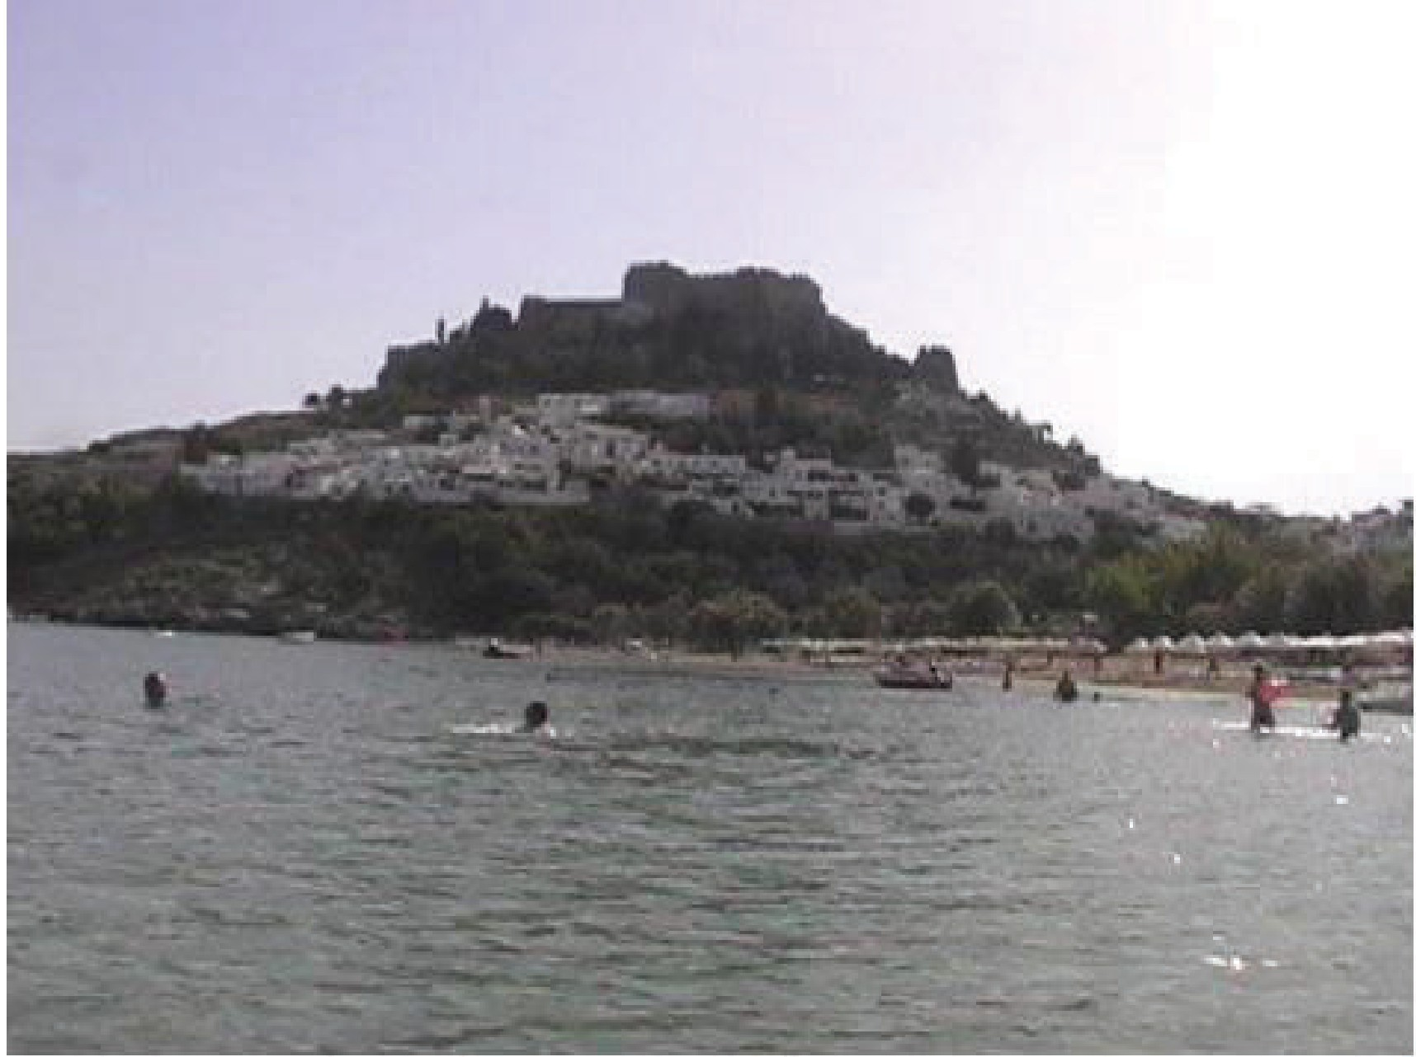

Athens
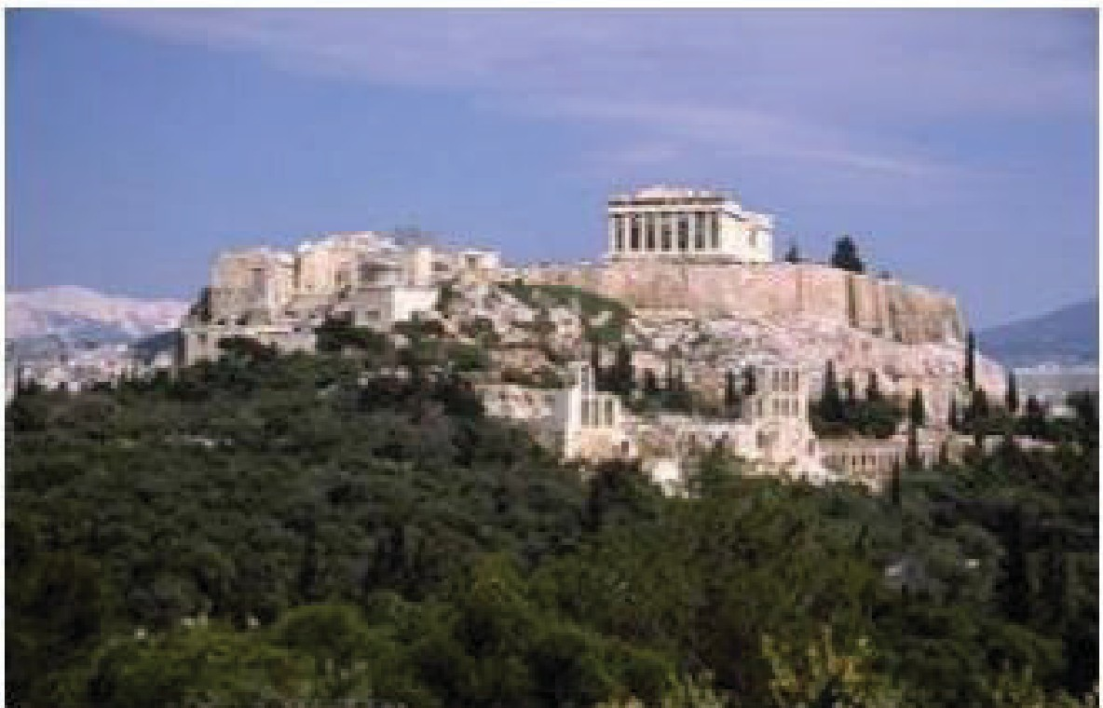
There are not many cities i11 the worl1d triat cap ure such beauty .and Inistorica.I srignifica11ce as the city of Athens. Here, in the city· of Gods, 1rh ere are many historicall sites, museums and c.ultu.raII spaces that a sblldent c.an VBsit U1e Acropolis Museum, the Byzantine Museum, the famous theater of Dionysu;s, the ancient Herod Atticus Odeo171, hhe
Ancient Agora of Athens. and U1e lycabettus Theater.

The Acmpohs of Athe111s has been a sacred site thmughol!Jit history_The prinoipall temple on the Acropollis i1s the Parthenon,, dedicated to Athena, the patron goddess of Athens. For Umusa11rds of years the Acrnpollis has been the symboll of AU!ens, the pr1ide and the gllo1ry of the city, the llinlk hat connects the ancient civi1l1ization w1ith the modem one. Bellow he Acropolis rests the Agora of Athens. The Agora was the heart of anciient Athens, the focus of pol1iticall, commemial, administr.aJtive and soaial adi1Vtity, the relli:g1ious and c.ul1lu1rall center, the seat of justioe.

Delphi
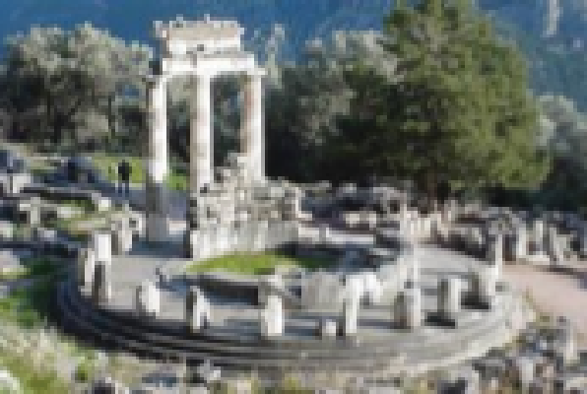
Located about 150 Km northwest of Athens is the ancient sandu1a1ry of Dellphi1, situated on the south side of mount Pa 11assus. During ancient times, Dellphi was regarded as the center of the world. There stood the Temple of Apolllo and the most famous oraclie of all antiquity_

Sounion
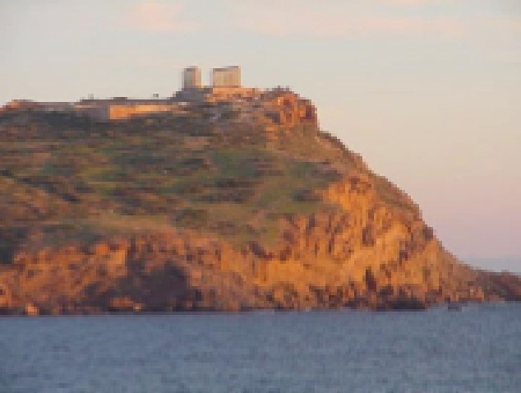
T17,e sanctuary of Poseidon at Sounio is one of the most 1important historical sites in Attica. The site was inhabited 1in 1:he prehistoric peri:od and is first mentioned in the Odyssey. Archaeologiicall 11iindlings datii11rg back to lhe 7n century BC prove that orgianized relligion had flourished in the regi:on. Souniion stands at the edge of the Samnilkos silr01re of Atti:ca, reminding alll of the mighty marine empire hat was.

Peloponnese
(all stu:dents): In Pellopon111ese shine some of the bright.est beaoons of Helllenic civi1l1ization. One can start the Joumey hrough time by admiriing the ancie111t city of Coriintl\ then INafpli'O,, hometown of the Bomtzii, an 1isllet covered with a mediievall fortress. Farther south one encrn.uters fhe ruiins of the ershiv[hile alll powerful! anciient Mycenaea111 civi1hzation as wellI as the town of Olympia, bir1hpllaoe of the
Olympic Games. From 1he southernmost part of the i1slland hails Spart:a, homeland of the heroic Leonidas, and haven to the maginifioent Byzan!Jine rnins of IMystras.

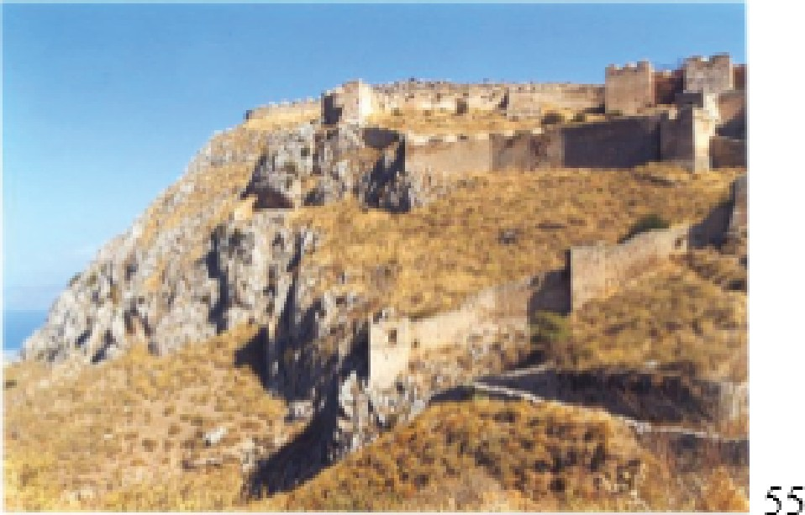
Ancient Corinth
Coriinth is mostly know11 after the 9¹¹⁷ centU1ry BC. It became a gireat navaII power that perfected the trireme. The mins of anciient Corinth are spread out at the foot of he huge rock of

Acrnco1ninth_ The museum contaiins mr0sa1ic floors, Mlycenaean and Corinthiian potlery;• term coUa sphiinxes, statues of hvo supernat1U1raII bein-gs engraved stones, etc_ Today Corinth (Korinthos) ranks among1Greece's most important ci ies_Tlhe Church of Saint Pa1UI reminds as the of the saint's Letters to the Corinthians a11d 1his preachiing at Corinth.
1

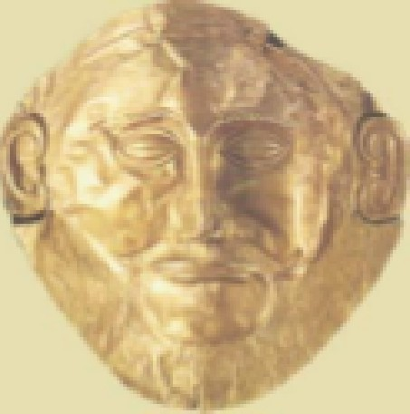
My;cenae
The ancients bellieved that the city walls were builid by the Cycliop1s creatures with supel'h uman powers_ Mycenae was the most powerfllI, brillliant and sovereign state of Greece fm:m 1i600 BC to 1100 BC. lit is the anciient home of King A,gamemnon, commander 1in chief of 1Jhe Greek army that des royed Troy foir the shake of a woma_n
1

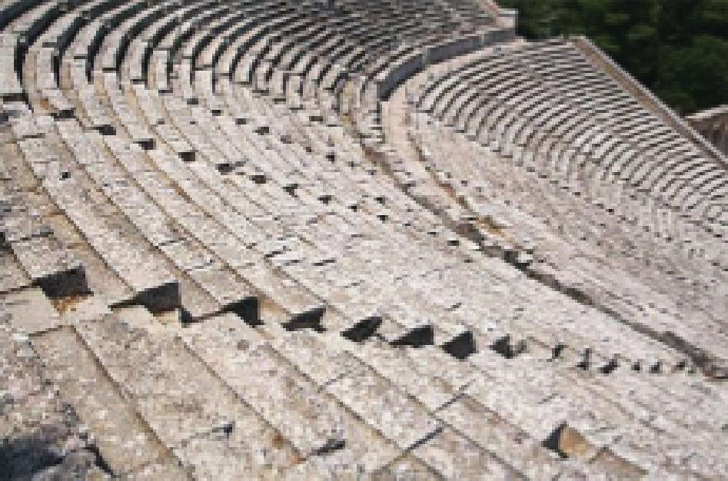
Epidaurus
The sanctuary of .Askl:epios at Epidaurus was the most oelebrated heal1ing center of ffihe ancient world_ Its finandal prosperirty in the ,tth and .3rd centuries 18C enabled the implemenltation of an amlbi ious buillding program for ffihe oonstrnction of a number of monumental buildings, such as he temple of AscJepios, the Tholos, and later hie Theater,
he Baths and the Palaestra_The Theater of IEpidaurus is the most famous and best preserved of all the ancient theaters in Greece Built of Iimestone can seat 10,000 spectators and is still used today for theatrical! performances.

Ancient Olympia
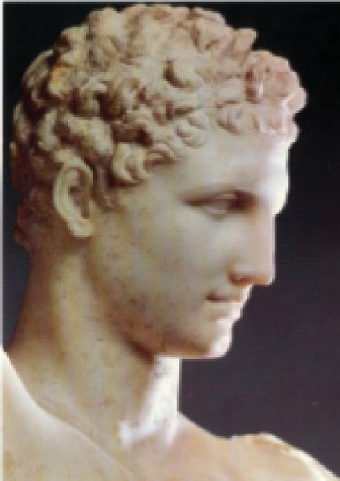
Here, in 776 BC the Olrympic games were dedicated to Zeus This day marks the first Olympi1ad; aftel"W'ards
1
every four years Pan-Helllenic contests were held
1
aUracting1athletes from all Greek oily-states. During the Games, the Olympic truce was in force and alI hostiii1tie.s were suspended. The victors pri1ze was a crown made from a wild olive branch which was always cut fro:m the same tree, the Kalllistefano. At the museum of Ollympiia the students can see some of the masterpieces of
Glassical Art such as Piraxiitelle's marble statue of He11mes, the victory of Paionios, Mittiades helmet, .and the sculptures from the pediments and metopes of the Temple of Zeus pottery1 terra cotta and bronze
figurines, votive offerings from the sanctuary, etc

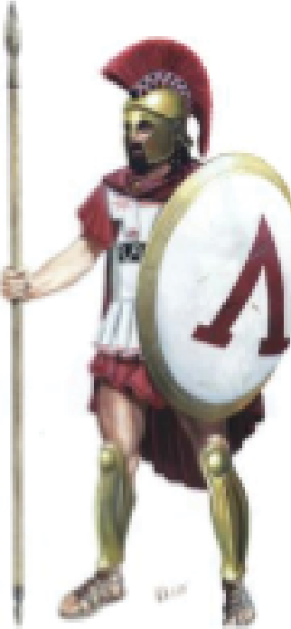
Sparta
Sparta is Uhe 1h istori1c capital of la conia w1ith r1U1ins of ancie11t acropolis, the sanduairy of Artemis, the tomb of ll..:eonidlas, a11id hie Meneilaion. It 1is the home of the famous Spairtan warriors.

The-rmopylae
lln 4H0 BC, three hu11diredl Spartan warriors stood aga1inst the 1Pers1ian armies at the Thermopy llae narmws. They fouglhltand died with honor refusing to submit to te11ror.

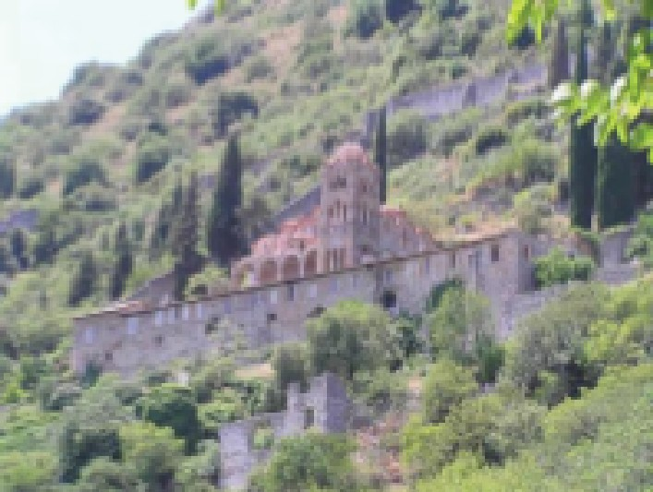
Mystras
Appiroachi11g IMystras (5 Km ffrom Sparta) a visitor feells as tho1U1g h he is making a pillgirimage to Byzantiine Greece. Walking uphill, the Castropo1rta i(the castile gate} wel!oomes our students ffor a waIlk thmugih the narrow lanes off hiis onoe 1invi1si1blle fortlress.
Strollling1Uhe narrow lla11es of the dead oity,, one ascent to the top of the castle. W1i11d1ing stai1rways, aircades, courtyards in ruins, wellcome Uhe visitor.

Meteora
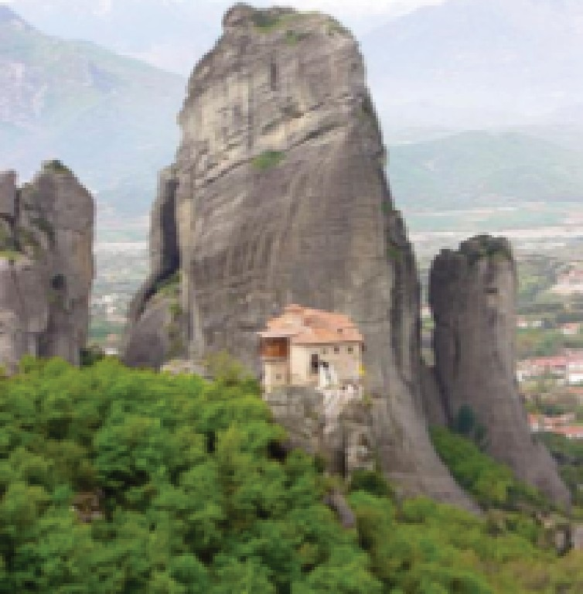
A. rare-geollog1icall phenomenon, a quirlk off nature as iit were, created these ]looming irociks whiich thrust slkywards ffrom Uhe plain off Ti\essaly, as if sllniving to come closer to God. Triese peculliarlly irnpressirve natural sculptures are known as Meteora because they do iindeed seem to han-g or hover i(meteorizo in Greek} above the pllain. The1ir summits,. totallly iisolated ffrom the rest of the worl1d,, were a refuge tor many lhe11mits ·firom as ear1Iy as the 11tti oenb.uy. From the 1fi h cent1U1ry monasteries were bu1iId and operate to present time. The monasteries have wonderful wall-painting1s, eodlesiasticaII
llreasures, rich IIiibraries with precious man1U1scripts, exquisite icons etc.

Dion
At the foot of mou11t Olympus stretches Dion, the ancient sacred] city of 1M aoedoni1ans.. Its name and its location connects the city diredly with the worshiip off "Olympian Zeus". Since 414 BC, a1hletic and pllarywri·glht games lastingi 111ine days iin honor of Olrymp:ios Zeus and the nine Muses were establlished. They were called the" lln Dion Olympia". King Phillip and his son

Allexander celebrated glorinus viidories at Dion_Allexander hiimsellf before setl:iing
1
off on his expedi ion, performed sacr1ifioes and,games in honor of Zeus at Dion.. Tile archaeological! eXJcavatiions of Dion started in 1924 and are stilll going1on
today. They u11earthedl a fortified city w1ith sanctuaries, building1s, stores, wo1Mkshops, private residences, publlic baths,, an odium, a theater, mosai:cs, and he i1mpressirve lrnmrioI1.J1s "VilIla of Dionysus"_

Vergina
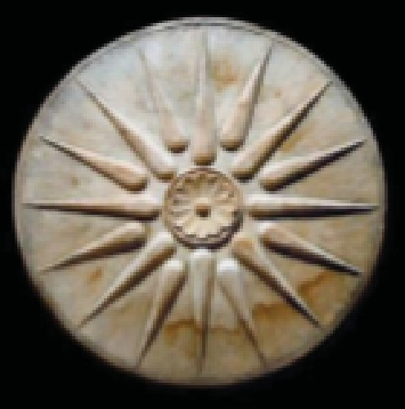
Vergin.a 1is the most celebrated archaeollog1icall site of Macedonia and pe1rihaps Greece_ Aliexandler he Great buried his ffather at Vergiina !Nith alllappropriIate honor. The
vallue and beauty ofhe sirte is 1U1ndisputed evi:denoe of the greab11ess and Greekness of ancient IMacedon1ia.

A!ianii
The oity of Kozani iis one of the most important a11d vibrant 1U1rban centers of Norilh West Greece_ llt is also
a town rich 1in culltu1re and history_ IKozani shows off its culture during the annllall Carnival cellebrations when he entiire town becomes a hu:ge dancingi ffl oor_ The public Iiibrary has rare ediiions, preci.ous manuscripts on parchments,, and historical documents .. The Hiistoricall-!Folklore !Museum and he Museum of Natural History off Kozanii are the among1 he best iin Greece_ About -30 Km away IKozani1ishie city of Aia111i wi h extensive archaeollogical excavations and a great museum_

Thessaloniki
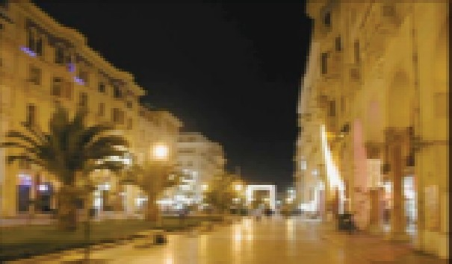

Thessal onikii is the second largest city of Greece_ It was founded 1in 316 BC and it was named affter the s1ister of Alexander the Great Today Thessaloniki is a modem and vibrant cosmopolitan oity that has somethiing to ofifer to alll tastes and interests. The shopping center of tile city is ffiirst class; he local! resorts are worl!d renown_ The c1ity 1is fillled with siites

and museums that willl impress he most demandin,g llover of Ancient, Hellienistic
and MedlievaIIhiistory.. Equalllly impressed ishe visi1tor who enjoys Modem Greek cullture and the Greek people as they go about theiir dailly bus1iness at a big ciity
with a smalll town dharader and know how to have fun_

Rhode,s-
Once upon a time,, the Sea created an island as ,ag1ift to the Sun god who named
it after hiis beloved IRhodes, daughter off Venus. The my h came into being1in order to describe the sun kiissedl beauty of Rhodes_ Todlay Rhodes has two ffaces, the old one, whi:ch, suriro1Lmd ed by the dty wallls, enc'Ioses the llife of yeste1rday, and the new, whiiclh, spreading outsiidehe city wallls, reflects the life of a modem city. !Rhodes has become a famous summer and wiinter resort

Cosmopoli1tan and at the same time traditiional;, Rhodes ma111ages to stay simple in flhle lliiie of its smalll villlages.

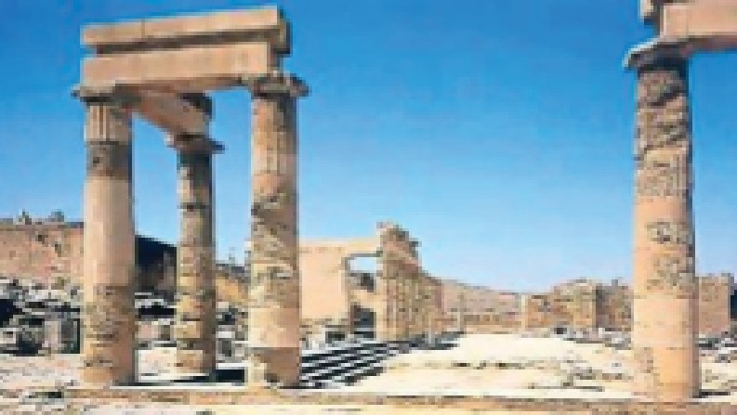
Lindo,s
About 35, miles southeast fmm the city of
!Rhodes iis fabled Lindos, a powerfLII mar1itime city in antiquity.. Pea ed by the unique, ftat­ topped rock formatJion, 11ising 400 meters above he bllue sea, is tile acropollis adorned with the Tempie of Athena, maki111g1 it trully
inspI1rmg s1ight .Amnng the marvells to
oontemp!late is the carv1ing in sollid rock of an anciient Greek trireme ship.

Kos
lln 36'6 BC the new town of Cos was founded and became one of tile principal! rading and maritime powers oii Greece. The Plane Tree of Hippocrates is
massive;he perimeter oii iits trnnk is at 12 meters. Legend has iiht at thiis was the
pllace where Hippocrates, flhle greatest teacher oii medicine iin anti:qui1ty, taught.

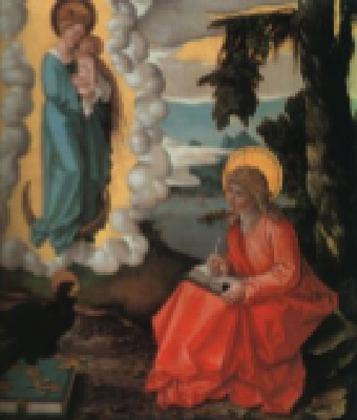
Patmos
Patmos is the isl!and oii revelations. It is a peaceful! is!landl
wi hl stmngi bi1bllical tiies _ The l!andscape of the iisland is darninated byhie massil'lle a11d formidable Monastery of St. John the DiMine_ St. John spent hNo years on Patmos, i111 a
gmUo where he reoeived, and IIater didated '"The IRevella ions" to hiis pupill, Prohoms.

Symi
Your first acquaintanoe with Symi is through its picturesque natural! port Egialo. Another excmsiion siite packet of iinterest i1s the IM0111astery of the Archangiell Michaeli. The monastery has a guest house, a treasu1fY and a chun:h adorned with oild iirescos.

IPAIDEIIAJUOA-.AUTH-UOIM-AU HCMR REGISTRATION FORM

PERSOI AL IDETA/ILS
Please use block letters (as written in your passport)

FAMIILY NAIME...................................................................Mir......Ms......
INAIME...................................................................................................
INATIONAUTY..........................................CIITIIZENSHII?...........................
IPILACE & DATE OF BIIRTH........................................................................
IPERMANENTHOMEADDRESS

STUDENT IIID#: ...................................................................................
TELEPHONE: .........................................................................................
E-MAIL: .......................................................................................................................

ACADEMIC IINIFORMA'TION

IMAJOIR FIELD OF sT·uD1Es,.......................................................................................
IMINOR FIIELD OF
STUDIES-......................................................................
DEPARTMENT/SCHOOL OF

EINIROLLMENT .......... ..... ._..._.
_......... .....--··
··_-··--

UINIIVERSITY/COLLEGE...... _................. _ ... _ ................_ .............. _ ......_ .........
YEAR OF ENROLLMENT........ _ .......... _ ........._ .......... ..................................

COURSES YOU \Ii/ILL ATTEND IN GREECE.

2. ·-·········-······-···-·········-······-······-······-······-······-·········-···-······-·········-··

3. ·-·········-······-···-·········-······-······-······-······-······-·········-···-······-·········-··

4. ·-·········-······-···-·········-······-······-······-······-······-·········-···-······-·········-··
5..

6.. - ....- -·--···-....- - ···-····-- ....- ---- . ··-..·--···-···--·-- -··- -···-..--- ...- ···----- ....- -·---··-....- - ··---·- - ....- --- -···-..-··

PLEASE STATE IRIEASOINIS FOIRCHOOSIING EACH ONIIE OF THE ABOVE IMENTIIOINED COURSES

1..
· · · ·
··-
· · · ·
··--·-
· · ··--·-
· · ·
··--·-
· · ·

2:_ - ....- - . - - ...- ...- - ...- ...- - ....- - . - - ...- ...- - ...- ...- - . - - ....- - ...- ...- - ...- ...- - . - - ....- - . - - ...- ...- - ...- - . - - ....- - . - - . -- .. --

3_ ··
··
···
··· · ·
· · · ·
·· · ··
· ··
· ···
···· · ··
· · ··-·

4..
· · · · · ·
·· · ··
· ··
· ···
···· · ··
· · ··-·

5 ..
· · · · · ·
·· · ··
· ··
· ···
····
· ··
· · ··-·

6 ..
··
···
·· · ·
· · ···
·· · ·
· · ···
· ·· ·
· · ···
· ··
· · ···
···
· ··
· · ··-·

COURSES IIN GIREEK DIR OTHER CIVIIUZATIONS YOU MIIIGHT HAVE TAKEN

1.. ·· ·
···- · · ·
·· -··
· ··
····-
-·· ·
· ··-·

2:_ - --- --- - . - - - • - - ..- - . - - -- - - . - - . - - - .. - - .- - -·- - .- - -- - -· - - - . - - .- - ...- - . - - -- - --- - . - - - .- - - . - - . - -··-- - . - - . - - - --
··

3_ · ·
· · ·
· · · · · ·
· · · · ·
· · · · · · ·

REASOINIS OF MOTIVATIION FOR IPARTICIPATIING IN GREECE PROGRAM

FOIREIIGINILANGUAGES OTHER THAIN ENGLISH (pliease state the level in
each Jianguage},

1_ · · · · ·-
· · · ·
·- -·-
· · ·
·--·-
· · · ·- · ·

2:_ - --- --- - . - - - • - - ..- - . - - -- - - . - - . - - - .. - - .- - -·- - .- - -- - -· - - - . - - .- - ...- - . - - -- - --- - . - - - .- - - . - - . - -··-- - . - - . - - - --

DATE ·_·- -_-_·--· ··- SIGNIATURE ··- --·

RJ.r'An::i:i.
C' FIDIITS.
'k:rK-12
HSI.J.B,l,O

SIU3.

.- ,-_-
ES

- -

PAIDEIA EDUCATOR IENRICHMENT GRANTS
Ap1plication Form

IDESCRlPTION

- Participation in a. short-term, intensive s,tu.dy program in Gr,eeoe which wi11:
  - suriv,ey the culture., history, archaeology, arts and litterarur,e ivith on-site le.am.mg at ancient Gr,eek sites ranging from the ,eolithic period to the present period,
  - offer opportm:Iities to observe the ropography, naJuraJl resources,
industries,and c.o.ntemporary culture of modem Greece.

- Development of a. portfoho that wi11 be used hy the app]icant m their edll.lica.tional s,ystem, instirution or classroom K-12_

PROCEDURES
  - APPUCATION PACK4GE INCLJJ'DES;
a Pecsona!l Information
- Portfolio Propos L A written proposal expbining how the candidate will apply the results of the study program ro 1he ir classroom, educational insti:tution or schoo] district
- Evaluation Component

- Statement indicaiting why the applicant ts interested rn the Educator Enrichment Program for Greek Studies
- Two Letters:
i.. One letter of recommendation fiom ,educationa] professionaJl
ii one letter fi-om th,e e<lucational institutjion/ di:s,trict vaJlida.ting
,employmem:and commitment to cmriculum presentation.
f_ App1ications must be po5bnarkoo no later than June 1 .and sent to the Center for Hdlenic Srudies PAIDEIA,

g. Appbcants, may con5ult wiid1 the Program. CoordinaJlior if th.,ey ha e any que5tions_

J,. UESCKWIIO iQ,f' APPLICAn,o COI\1LPONENIS:
- , PORTFOLIO PROPOSAL.
  - C1!1JrrionluD1:
[ _ length.of time
  - defined
J_ Sicope
- goals
- components
  - R.atioiDale:
[ _ how does the proposed cu.rriculnm r,ebtes to the applicants:
fi.cld
2. what need will this curricuhm1 meet
iii R.,esooroe unit
L Sicope
2. goal
iv. ,c;3;tegories::
[ _ materiaJ!s wt·ilim. US deve]op a. sdect hiibliography: w b
sites, books.,reSiearch
2. materia]s from Greece.

- , EYAL[UTJ01V COMPONENT
  - ]n Greoce: focus group participaitio evaluation report
  - ]n the US: .asses:sment of the outoom.es of the portfolio after it is
presented ro smdents
iii By Paideia wiU be able to survey student participants and
observe implle.mentation of the P'ortfoho.

3,. CRITERIA. FOR. :PORTFOLIO

a. Standards for development of the portfo]ios wiUbe pro.ided to candidates
who roceiN,e a HeUeruic Society Paideia Grant

PERSONAL INFORlvlATION

- Name:
(llast]i (first)

- Home Address

- Tellephone(home)

- Tellephone(worik)

- Email

- ISdlucationallinstibJrtion name & address

- EducationallinstibJrtion (phone)

- Posirillion heId

10. CREDIT
□1 Certfficat,e off parti:dpafilon.

PROPOSAL

A STATEIMEINT OF !INTEREST IN TIHE TEACHER
ENIIRIIGHMEINT PROGRAM FOR HIIELLENIIC:STUDIES

- CURRICULUM:

ILIBN<Ii'll"IHI @

  - GOALS
0 1.

0 2.

0 3.

0 4.

  - COMPONENTS of CURRIICULUIMI
0 1.

0 2.

0 3.

0 5.

0 6.

0 7.

M1rnrIDNAILIE
- HIOW' DOES THIE PIROPOSIED CURRICULUM IRIEILATE TO TIHE APPLIICANIT'S IFIIELD?

- WHIY IIS THIIEIRE A NIEIE□FOR THIIIS CUIRIRICULUM?

l!YJMI.Mirmnim,oom • n w
  - Assessrine1111t m1easures that willI be us,ed to evaIuate this curnicullum and resource k1it

I■

I■

I■

I■

I■

C. RESOURCIEKllf

GOALS

CAT!GORIES OF MAT!RIAJL
Attach infonmation indiicating Um res,ourceis.(books. web sites)
and the materials (bib]iographies, res,earch) that wiU be gathered in:
United States
Gre,ece

lEITERS OF REFERENCE

Please .ask hvo persons, to submit a letter in support of yom proposal Letten, of recommendation should be ,vritten on institutional stationery and sent to the Center of Hcl]enic Studies PAIDEIA (note addrnss) ma sealed ,envdope_
Letters may he from an administrator, from the dep.a:rtment chair, or a colleague_

Please indicate the names, and addresses of the persons whom you have asked for
refer,enoes:

Reference 1.

Reference 2.

Amount re1questedlf.,-om1Center for Hellllen1ic Studies Paideia:
GRANT.REQUES,T..

Amount app,Ii:canl is p1aying:

REQUEST FOR RELATIVE TO ATIEN1D.

111a1me:
r,elationship:

age (onl I' ff re q est is ior sonJdaughiler):

SIGNATURE DATE

Paideia\Educator Emclrment Program Coordinator Center for Hellenic Srud1e"s Paideia =
28 Dog Lane :P.O. Box 818 Storrs, CT 06268-0818
Tel: (860)906 8458
Email: paideia@snt.net
WWW .hellemcstudiespaideia...org:,WWW .paiderausa org

11Clhecklist
Paideia

Pa | ii'd | :e | ,ia | IProgram

Not necessarily in chronological order

A.
FOR YOUR STUDENl'TVIS.A

Paiideia IProgram1Checklist
Not necessarily in chronological order

A. FOR YOUR S.lUDENll"VIS.A

- · Complete your study abroad appllilcation..
- Meet with a ·fiinarn::ilall a1id offiice if yoiu are a financial aid recipilent.
- Attern:::I orientation
Start ,gatheringi he doc1U1menta11Jion fur the Vlisa_ You w1ill need:

- A vallid 1passpo:rt
- Two IPhotos (get 4)
- A Ietter fr,om FBII sta ing1that y·101U1do1 no,t haVie a. c:rim1mnal record. For
Expedited service y,ou can go at:www.accuratebiometrics.com,. You
,can caH at ·tel1epihone # (773,)'685--569191; Fa.x :#(77'3)6,85,-543,3,. "li"-'i"
- Fiinger p:riints from your IIocall pollice depa1rtment
- A mrediica.t fo,r1m com[Plet:edlby your doc.tor statin1g that you are free f'r1om contagious disease. You 1may need to ,get a TB test ifi yoll.JI have not had one done recentlry..
- A,co1p,y of your :s·tudy abr,oad iins.urance coverage.,llf your schooil iis not:IPro,vidiing as p,a1rt:o,f your r1egiistr:at:i,on fees ·f01r study·Albr,oad I1111su ra oe coverage you can g,o at: www.HTHworlwJde.com or at www.cm1-1nsurance.com,.
- Y,our fili,ght itiinerary
- A l,etter of acoe1p1tanoe firo1m t e Univ1ersii1tyiin Grieece.
- An .accepta1nce Ietter fr-om P.aideia.
- A co:mplleted and si,g1ned ·visa ap[pIiicat110:n form1
{http://www.greekembassy.org/embas.sy/oontentlen/documenfs/embassy greece visa applicatio _doc )
- For the return of y,ou1r [piasspo,rt a s,elf addressed o,vem'i1g1ht:e1111velo1pe,
,only·, from .a US P'DST OFIFICE..,

You1111eedl to go in person to Greek Embassy in Waslhington] DC or to your nearest Consullar offices of Greece (INlew Yor1kl Boston Ta1mpa] Chi:cagol San
rancisoo] Los Angelles1 Atlanta] Hou1ston).

IPPfiDEIA STUDY ABIROAD PROGRPfiM IIN GRIEECE

EMERGENCY
1COINTACT FOIRM

Dates:

Your N | lame:
Address:

Telephone: If 01.J are,bringiing prescribed medicati:m1s, li:ston separat,e page
111s11111.uan c.e Provider:
Policy number:
Telephone numlber:
Do you have coveIr-a:ge for Greece: llf 11101, what other arrang1eme11ts have you made?

Pilease prov1ide me name{s} a11dl address{e.s} of Ipeople in the U111ited states who ran lbe co111raoted 1in case of an emergency WH IILE WIEARE.IN GREECE Ust 2 people to
conraot in ORDER OF PRIORITY:

1) Person to i0ontact:
ReI1 | Iationshli | 1p to you:
Street Address:
City: |  |  | State: | Zip:
HloI | m1e phone:: Woirt< phoine:
2) Person to oontact
Rell | lamionshiip to you:
Street Address:
City: |  |  | State: | Zip:
H101 | m1e phone· |  | Woirk phone

Studenfs

SS# INuml
Date o,f bi
TRANSCRIIP'T 'TRANSFER FORIM
This form 1must be returned w1ith yo1U1r appllication_

Studenfs .

,.u ............

Permanent Home .Add1ress
City State ZIIIP _

'Tellepho:ne Nlumber _ Student ID#

Nla1me ,of Study Abroad
P1rogram

Dates ,of AHenda111,ce

IPllease send an otticilal transcript of my ac.adem1ic record to the follllowing 1reci1p1ient
(p:riint a111iinfonnatiionde,arlly and •complet,elly):

!Recipient

II he ireby a11.Jthorize Paidle:ia Study .AJbmadl pmgrarns to rellease my official itJransciri1pt to the recipi:ent named above_

DATE J I
Sl7Ul!DENI'S SIIGNlATURE

RETl.lllRIN COMPLE'T1ED FORMS l"O:

PAIIDIEIA STUDY ABROAD PROGIRAIMS
Ce nteir fo:r Hellleni:c Studies IPaideia
28 DOG LANE,, STORRS, CT 062'68-0818

HEA!llili IINIIFORJMAllUN
NAME

HOME SCHOOl

HEALTH HISTORY FORM

PR.0GIR.AM

LOCATIIONIOF PR.0GIR.AM

HIEIGHl

NAME OF ANIY DIISEI\SE, .AIILMIENfS, IINJURJIES

Vi/EIGHT

AR.E YOU CLiR.RENITLY UNDER THE CAR.E O:FA PHYSICllA!NJOR AN'f HEAl TlrllCARE
PR.OFESSIION\AL? IF YES, DESCRIBE TlrllE SllUATIION

WIHIAT. MEDICATIONS ARE YOU CUIRHENTLY TAl<llNG, IF ANY?

AllERGIES

AR.E YOU ON A RESTR.IICfED DIET?

AR.E YOU A. VEGElER.llAJN

ARE. YOU SEIRJIOLilSLY UNIDERWEIIGHT OR OVERWEIIGIHIT?

DO YOU SMOKE? DO YOU hlAVIE.ANfYPHYSICAL DIISABIILillES?

HAVE YOU H.AJD ASTIHMA OR ANY OllHEI R IRES!PIIRATOR.Y .AIILMENT?

DAYTIME PHONE NUMBER OF PARBNT OR GUAJRDIANI

llf ann!liicab11e, roolifilmate, erenc.e
ti"'ll-'' It"" ---------
·1 •

PA DEIA OUSING AGREEME 11'

I understand Uh a1t the Pai:deia wi1III provide hous.ing1for me iin an apartment shared with other progIram1 participants;, th1at each situai'tlion 1is neoessarily diftereint; and that the progiram director willl make every effort to e11sure my com1furt and we1I1-lbeing.

Please read izstudent Ha1111dlbook in Greeoe;,)carefullly. If Uhe Resident Director determiines that a student must be removed from hiis her apartment due to unacoeptablle behavior] desl:n1dio111 of property] excessive dri1111kling, disrn1ptio111 of the l1ives of room1matesl and if such student is permitted to oontinu:e as a program participant alternative IIiviing anrangements willII be made at the exJpen se of Uhe student.

I understand that if I change acoommudati:ons volluntari1ly, the Prog1ram willl
not be responsilble Jor f1inding oUher accommodations for me,, nor wiIll it be involved in rent payments] etc.; and that since the Program co1111tinues to pay·fur he space I ori,ginaIlly oocupied . I cannot expect to be reimbursed for housing1 expenses. Due to the fact 1hat hous1ing i1s l!easedl by semester,, there willl be no housing reifiLmds to students who withdraw from Uhe program or who are dismissed._
1

I further understand that the use of the apa1rtments i1s si'llr1ictlty for the use of program partiicipants and that occupancy in a1111y fo11m by persons not enrollled in he Program will not be alllovred. Addi ionally petslaniimals are not permirtited.
1

I u1111derstand that no posters, plhotographs] or a1111y h in-g else may be attached (by scotdh rape] tack, pin] niaiiI] etc.) to the wall1s of the apartment unless he apartment owner has put it there 1h imiself.

A mandatory $200 deposit fur housingI dam1age willl be collected trom the
students upo1ni arrival! and will be reimbursed at the end of the program if there are no damages, a11d unpaid p1h one lbillls_

Signature

PAIIDEIIA''s Crisiis Res1ponse:
PAIDEIA's USA Office upon receiving a calll from1the Program Assistant Director (or 1from odler staff members, parent or ol:her source)] involvingi a serious injury death or emergency willl:
1
1
1_ IIn irtiate a ser1ies of phone rallls
- Get the fulllowing informati:on frorn1mre Program director:
  - !Niame of calier and of victim(s}, if any
  - Bri:ef desoniption of accident] inj]ur1ies, and/or eImerg:encyl the steps th1at 1h a\i\e been taken and the status_
  - Location oir calier in Greece
  - Location of accident or emergency. How close is irt to students and staff?
  - Phone ceIll phone, fax. or beejper num1ber where calller is
I 1
  - IFiind out if resc1U1e squadl locaII IIaw enforoementl U.S. embassy/oonsu !late have been callled it appropr1iate?
I
  - Has any information been rel1eased to he media?

llf an emergency - real or perceirved - occurred] si\ould ask for deta1iledl answers to hese quesaons:
  - VVhat impactl 1if any, did an t eImerg:ency have on availlabil1ity of food, water; and medical suppllies?
  - VVhat was the target of unrest1 1if the event was pollinical?
  - VVhat is he intensity of the em1ergency or of the polliti:cal unrest?
  - . re there 1millitary or emergency personnel at he site of the emergency?
  - I1s continuation of cllasses feasible?
  - How able are our students and staff to uravel 1in the country?
  - What is the adivi:ce of the nearest U.S. embassy or consullate?
3 No statements slhoulid be made to the press
4. llf an emergency has occurred;, calll he LI.S. Department of State Oitizen Emergency Center fmm1 overseas is 202-501-4444 for suggesuions or assi1stance _ A.ffihens American Embassy: 210-721-.2951 or 7221160; fax: 210- 524-408 8. In Thess aloniki: 23,1OL242905;,6,l 7 _
Also caII immediatelly Greek Police at 100 oir 112] For Ambulanoe 1i66; IFor
Fire Br1igadle 166,_

FALL SEMESTER SAMPLE ITINERARY: All programs
Day 1 Arrive in Athens, Thessaloniki, Rhodes Orientation

Week 1-8 Regular classes
Week 9 Meet in Athens November 18.
Cultural excursion and study tour for a week

Week 12 Finals; program ends

SPRING SEMESTER SAMPLE ITINERARY: All programs
Day 1 Arrive in Athens, Thessaloniki, Rhodes Cultural excursion and study tour for a week
Week 1-11 Regular classes

Week 12 End of semester

Disclaimer
The information on the 2022 - 2023 Paideia catalog is provided solely as a convenience. No contractual liability is assumed. Because the manuscript was finalized in November 2021, this publication should not be assumed to be currently complete and fully accurate. Itineraries given are approximate. Dates and activities are subject to change without ad- vance notification. Specific itinerary will be announced upon arrival.

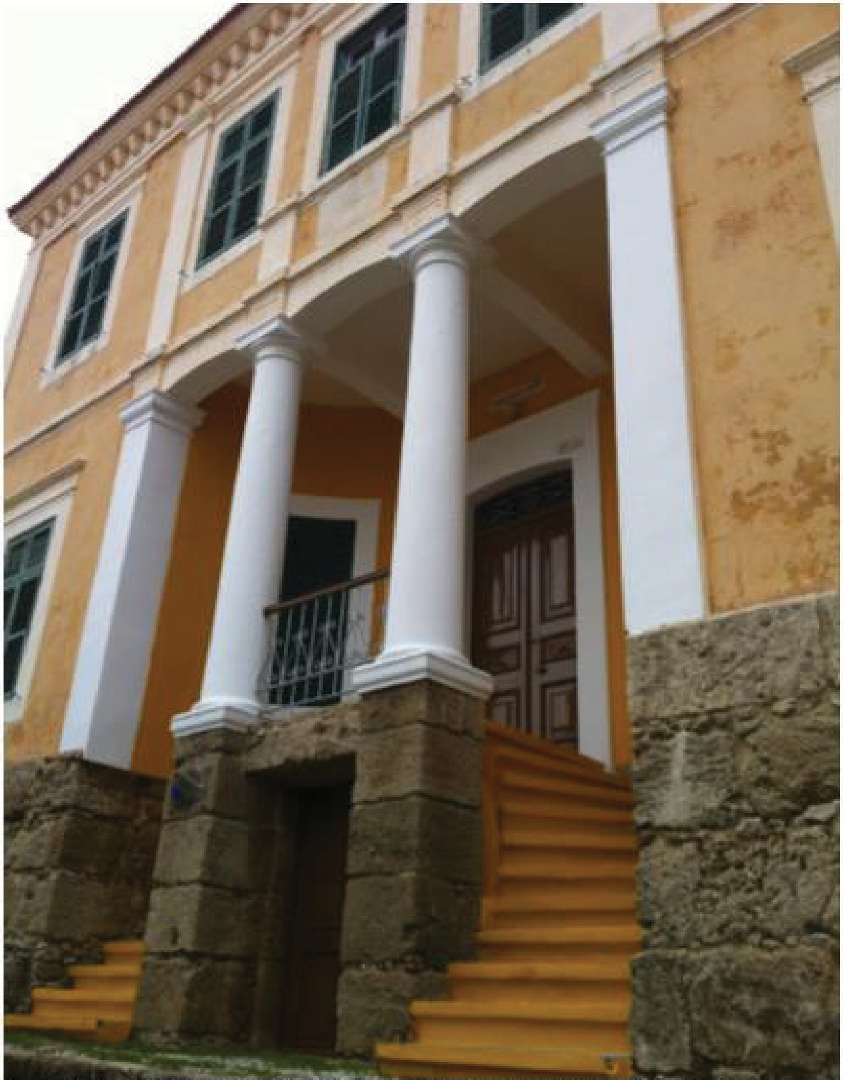

PAIDEIA RHODES Study Center for Hellenic Studies
J

For more information:
Center for Hellenic Studies.Paideia or Paideia.Study Abroad Programs.in Greece
2:S Dog Lane., PO BOX 818 Storrs CT 06268
Tel; (860)906-8458
.Email: paideia@snet.net

Paideia Programs in Greece Tbeophiliskou 13
,old City of' Rhodes.
Rhodes Greece 85 100 Tel. (22410) 39421
WWW.hellenicstudiespaideia.org

